Staged System Tests for Validation of WECC System Performance and Modeling:

Summary Report for August 19, 2008

Partial draft of October 10, 2008

J. F. Hauer, PNNL

W. A. Mittelstadt, BPA

J. W. Burns, BPA

K. E. Martin, BPA

Harry Lee, BCH

D. J. Trudnowski, Montana Tech

(others to be determined)
TABLE OF CONTENTS
1.0 Preface 2
2.0 Summary 2
3.0 Introduction 3
4.0 Test Overview 4
5.0 Observed Values of Interarea Modes 8
6.0 Some Basic Aspects of Modal Analysis 11
7.0 Observability of Chief Joseph Brake Insertions 14
8.0 Observability of Random Probing Signals 16
9.0 Ambient Correlation Signatures 22
10.0 Correlation Analysis for HVDC Probing with Low Level Noise 26
11.0 Transfer Functions for PDCI Terminal Response to Low Level Modulation 30
12.0 Prony Analysis of Brake Insertion on C1 on August 19, 2008 30
12.1. Modal Analysis of Ringdown Signals for Brake Insertions [update this section] 33
12.2. Integrated Modal Analysis of Ringdown Signals for the Western Interconnection 36
12.3. Discussion of Ringdown Results 40
13.0 Cross Validation of Recording Devices 42
13.1. Cross Validation of PDC Records 42
13.2. Cross Validation of Records from the Celilo PPSM 42
13.3. Cross Validation of Records from the Dittmer PPSM 43
13.4. Cross Validation of Records from Special PPSM Units 45
14.0 Actuator Performance of the Pacific HVDC Intertie 45
15.0 Initial Results with ModeMeter Codes 49
16.0 Conclusions 49
17.0 Acknowledgements 51
18.0 Glossary of Terms 51
19.0 APPENDIX A. Test Sequence for August 19, 2008 54
19.1. Test Series A: Calibration Checks on PDCI Probing Signals 54
19.2. Test Series B: Noise Probing 54
19.3. Test Series C: Cross Validation of Probing Methods 54
19.4. Test Series D: Noise Probing 54
19.5. Test Series E: Noise Probing 55
19.6. Test Series F: Noise Probing 55
19.7. Test Series G: Brake Application 55
20.0 APPENDIX B. Playback Files for HVDC Probing 56
21.0 APPENDIX D. DSA Applications During Low Level HVDC Probing 57
References 61

Preface
This is a summary report on the probing tests of August 19, 2008. It provides a general description of the tests, the observed effects of the test procedures, and a brief cross section of analysis results produced to this point. General methodology and a detailed summary of earlier test results are provided in []; an overview is provided in []. More detailed analysis will be presented in future reports, which will make wider use of analysis tools being developed under the ModeMeter effort [,].
Though not exhaustive, the underlying analysis summarized in this report is already very extensive. Much of this consists of annotated PowerPoint slides that serve as a running log of analysis results. Such materials are embedded within the WAMS event archives, in folders such as _ACDCtests081908_Reports. The events are “date stamped” there in the format YYMMDD, rather than MMDDYY.
This Report is intended for general use by the DOE, CERTS, and associated technical groups of the Western Electricity Coordinating Council (WECC). Many of the reference documents represent a collective effort by one or more WECC technical groups, and in many cases the work is still ongoing. Access to those documents that have not been generally distributed is controlled by the appropriate WECC authority.

Summary
During 2005, 2006, and 2008 the Bonneville Power Administration (BPA), in coordination with WECC technical groups such as the DMWG and the M&VWG, performed four major tests of western system dynamics. The primary objectives of these tests include the following:
A. Obtain seasonal benchmarks for dynamic performance of the WECC system
B. Develop comparative data to evaluate and refine the realism of WECC modeling tools
C. Refine and validate methods that identify power system dynamics with minimal or no use of probing signals
All data for the test were recorded automatically by the WECC WAMS, or with ordinary SCADA systems. System conditions during the tests were within normal limits, though testing in September 2005 was done with the Alberta system was islanded from the remainder of the grid. Though not common, this is a normal condition that usually occurs for several days each year.
The tests produced an excellent profile of WECC dynamics across the entire grid. Response to probing signals was strongly observable in the western regions, and clearly apparent at eastern locations such as Four Corners and NE Colorado. The most recent tests, in August 2006 and August 2008, benefited from newly installed PMUs at several generation sites in western Canada. Several of these plants are critical to wide area dynamics [], and this extension to WAMS coverage is a major contribution to surveillance of wide area interactions across the western interconnection.
Spectral signatures for brake insertions in 2006 and 2008 fit a general pattern that extends back to energization of the 500 KV Alberta connection in 1987. The insertions on 09/14/05 match a different but equally consistent pattern that results when the Alberta connection is not in service. It is strongly recommended that the M&VWG use these patterns as a general check on the realism of WECC planning models.
As shown in Table 1, damping for the primary interarea modes was rather high for brake insertions during all of these tests. By comparison, during the late 1990’s damping for the first three modes was often near to 6%.; prior to that time a damping of 4.5% for the North-South mode was not unusual.
System conditions on 09/14/05 represented a normal but uncommon system topology, for which the Alberta mode is not present and frequency of the North-South mode is much higher. Data from the tests in 2005 and 2006 were subjected to very thorough analysis, and the values shown for them in Table 1 are benchmark results that are representative for a number of signal combinations and analysis procedures. While results for the 2008 test represent work in progress, final results are not expected to differ materially from those shown in the table.
Table 1. Primary modes from Brake Insertions
Mode D1 on 09/14/05 B1 on 06/13/06 B1 on 08/22/06 C1 on 08/19/08
North-South 0.318 Hz @ 8.3% 0.244 Hz @ 9.1% 0.244 Hz @ 9.6% 0.247 Hz @ 9.7%
Alberta (not present) 0.376 Hz @ 9.1 0.373 Hz @ 8.1% 0.363 Hz @ 9.3%
Kemano 0.626 Hz @ 15.4% 0.620 Hz @ 8.8% 0.642 Hz @ 9.9% 0.629 Hz @ 13.3%
Colstrip 0.889 Hz @ 10.7% 0.776 Hz @ 10.2% 0.830 Hz @ 10.9% 0.791 Hz @ ~20%

Of particular note, the tests with low level noise demonstrated good results with a probing signal that roughly doubles the apparent noise that is natural to the power system. This additional noise is essentially invisible to all but the closest examination, and would probably be acceptable for general use as a background tool for surveillance of system dynamic conditions.
ModeMeter codes for this purpose are briefly examined in a separate section, where results consistent with Table 1 are obtained by time series analysis of system noise records. Such results seem to require a record length of roughly 20 minutes. The development of these algorithms is being pursued very actively, and detailed progress is reported in a separate series of documents.
The processing and many of the results for the August 2008 tests are closely similar to those for the tests in August 2006. The earlier report [Error: Reference source not found] presents many processing details that are not repeated here.

Introduction
Performance validation of power system dynamics makes integrated use of measurements and models, and it must address many aspects of system behavior in which oscillatory dynamics are not a key issue. Probing tests, and the accompanying analysis of oscillation modes, must be designed and conducted within this broader context.
However, within the narrower context of oscillatory behavior, the following attributes of wide area oscillation dynamics are of paramount importance:
a) Mode parameters (eigenvalues). Usually characterized in terms of frequency and damping.
b) Mode shape (eigenvectors). Characterized by the relative phasing and strengths of generator oscillations for each mode. Eigenvector signatures are specific to associated system events.
c) Interaction paths. The specific lines, buses, and controllers through which generators exchange energy during oscillatory behavior.
d) Response to control. Modification of oscillatory behavior due to control action, including changes to network parameters and load characteristics. Usually characterized in terms of transfer function poles and zeros.
A fully realistic model for wide area oscillation dynamics must, for all important modes, replicate and predict all of these attributes for the actual system. Probing tests, and the accompanying analysis of oscillation modes, must address these same attributes and extract key information for real time use.

Test Overview
During 2005, 2006, and 2008 the Bonneville Power Administration (BPA), in coordination with WECC technical groups such as the DMWG and the M&VWG, performed four major tests of western system dynamics. The primary objectives of these tests include the following:
A. Obtain seasonal benchmarks for dynamic performance of the WECC system
B. Develop comparative data to evaluate and refine the realism of WECC modeling tools
C. Refine and validate methods that identify power system dynamics with minimal or no use of probing signals
Distinguishing features of these tests were a strong focus on Objective C, plus greatly improved instrumentation and software for achieving this objective [Error: Reference source not found,,,,]. All data for the test were recorded automatically by the WECC WAMS, or with ordinary SCADA systems.
The tests included the following staged events:
• Energizations ("insertions") of the Chief Joseph dynamic brake
• Insertions of brief sine waves and square waves by modulation of the Pacific HVDC Intertie
• Insertions of sustained random noise by modulation of the Pacific HVDC Intertie
• Synchronized recording of ambient background activity in network signals
General guidelines for such tests are presented in []. Previous versions of these tests are described in WECC documents such as [], and a concise summary of tests performed in June 2000 is available as []. Detailed reports on various aspects of all recent tests are available or in progress as [,] and similar documents.
The tests were performed on the dates shown below:
• Test05A: September 13 -14, 2005 (Alberta system islanded)
• Test06A: June 13, 2006 (Alberta strongly connected)
• Test06B: August 22, 2006 (Alberta strongly connected)
• Test08A: August 19, 2008 (Alberta strongly connected)
Test05A followed the two day schedule shown in [] and []. The tests in 2006 and 2008 followed one day schedules such as that shown in [] and in Appendix A.
System conditions during the tests were within normal limits. Conditions for Test05A were not typical, in that the Alberta system was islanded from the remainder of the grid. This condition persisted throughout the test period, and it shifted the interarea modes into a configuration that is expected for only a few days per year.
The tests produced an excellent profile of WECC dynamics across the entire grid. Response to probing signals was strongly observable in the western regions, and clearly apparent at eastern locations such as Four Corners and NE Colorado. Table 2 and Fig. 1 are summary guides to the many geographical locations that are indicated in this Report.
Of particular note, the tests with low level noise demonstrated good results with a probing signal that roughly doubles the apparent noise that is natural to the power system. As illustrated in Fig. 2and Fig. 3, this additional noise is essentially invisible to all but the closest examination, and it would probably be acceptable for general use as a background tool for surveillance of system dynamic conditions.

Table 2. Summary of PMU names and locations
WSN1 Williston Central BC
MIN1 Minette West central BC (near Skeena)
GMS1 GMShrum1 Central BC
GMS2 GMShrum2 Central BC
MCA1 Mica South central BC
REV1 Revelstoke South central BC
NIC1 Nicola South central BC
SEL1 Selkirk SE BC (north of Boundary)
LA01 Langdon Calgary Alberta
ING1 Ingledow SW British Columbia
CST5 Custer 500 NW Washington
BEL5 Bell 500 Spokane WA
COLS Colstrip SE Montana
GC50 Grand Coulee500 Central Washington
BE50 Big Eddy 500 Lower Columbia river
JDAY John Day Lower Columbia river
MALN Malin California-Oregon
SYLM Sylmar Los Angeles basin
SCE1 SCE Devers Los Angeles basin
PV50 Palo Verde 500 Near Phoenix AZ
FC50 Four Corners 500 NE New Mexico
BEAR Bears Ears NE Colorado

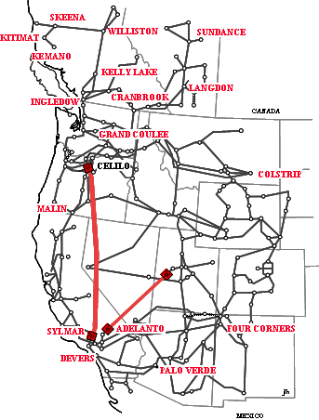
Fig. 1. Key locations in the ACDC tests of 2005-2006

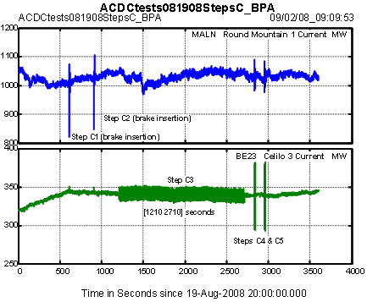
Fig. 2. Event timing for test steps C on 081908
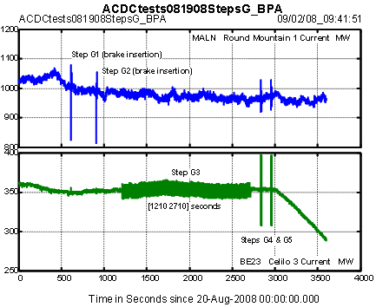
Fig. 3. Event timing for test steps G on 081908

Observed Values of Interarea Modes
Test insertions of the 1400 MW Chief Joseph dynamic brake provide a quick view of modal parameters, together with "ringdown signatures" that are readily compared against historical data. These signatures also produce convenient benchmarks for validation of transient stability programs.
All of the tests reported here involved two or more insertions of the Chief Joseph dynamic brake. The modal parameters shown in Table 3 summarize analysis results at this point. Though subject to refinement as analysis methodology evolves, these parameter values are consistent with tests in 1999 and 2000, and with a variety of other observations that have accumulated over the years. A summary description of the 1999 tests is provided in [Error: Reference source not found] Appendix F, A Primary Benchmark on Effects of the Alberta Connection.
Table 3. Primary modes from Brake Insertions
Mode D1 on 09/14/05 B1 on 06/13/06 B1 on 08/22/06 C1 on 08/19/08
North-South 0.318 Hz @ 8.3% 0.244 Hz @ 9.1% 0.244 Hz @ 9.6% 0.247 Hz @ 9.7%
Alberta (not present) 0.376 Hz @ 9.1 0.373 Hz @ 8.1% 0.363 Hz @ 9.3%
Kemano 0.626 Hz @ 15.4% 0.620 Hz @ 8.8% 0.642 Hz @ 9.9% 0.629 Hz @ 13.3%
Colstrip 0.889 Hz @ 10.7% 0.776 Hz @ 10.2% 0.830 Hz @ 10.9% 0.791 Hz @ ~20%

Fig. 4 shows that spectral signatures for the brake insertions on 08/19/08 are quite consistent with those extending back to 1997. The same general pattern extends back to energization of the 500 KV Alberta connection in 1987. The insertions on 09/14/05 match a different but equally consistent pattern that results when this connection is not in service.
Fig. 5 through Fig. 7 show representative ringdown transients on the Malin-Round Mountain. Most of the waveform changes in these figures represent normal variability in power system response. While the transients in Fig. 6 are very similar in the short term, Fig. 7 shows longer term differences suggesting that some kind of control action may have occurred as a “hidden input” to the system.
The ringdown characteristics in Fig. 5, which are notably different from those in Fig. 6, represent normal behavior when the Alberta system is islanded from the remainder of the grid. The differences are conspicuous in the frequency domain profile of Fig. 8, in which there is no spectral peak for the Alberta mode and the North-South mode has increased in both strength and frequency.

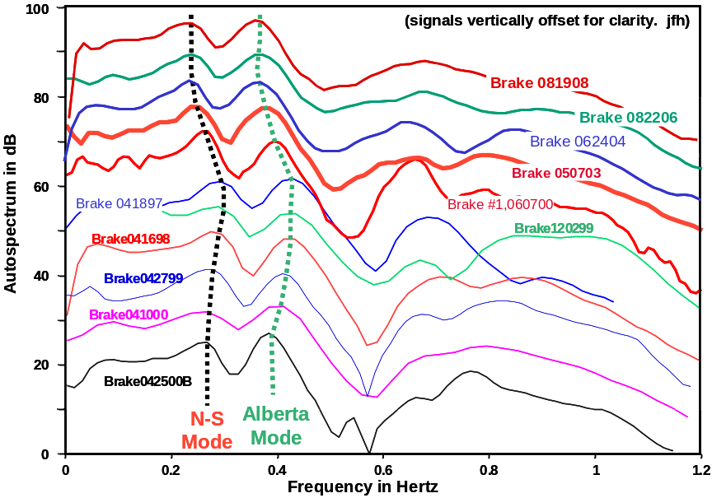
Fig. 4. Ringdown signatures for recent insertions of the Chief Joseph dynamic brake
(Alberta strongly connected)

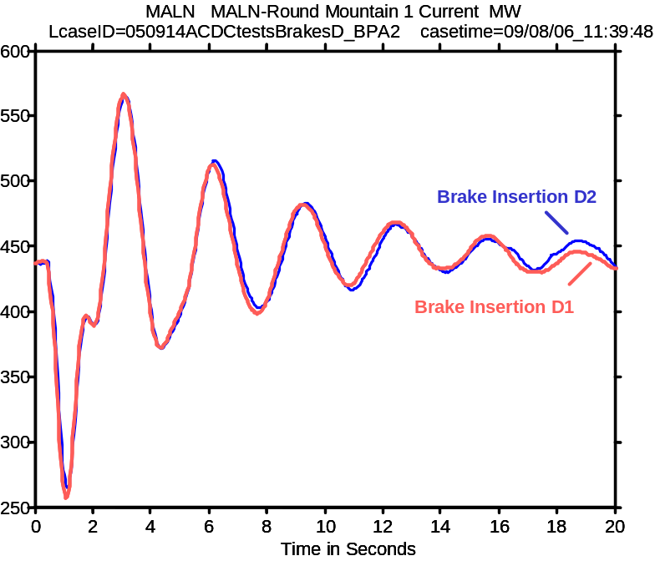
Fig. 5. Ringdown transients on 09/14/05

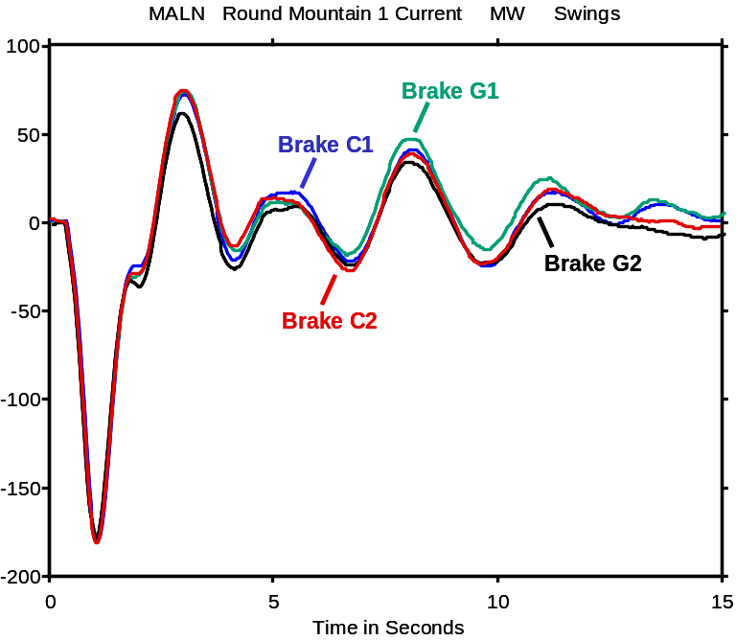
Fig. 6. Ringdown transients on 08/19/08
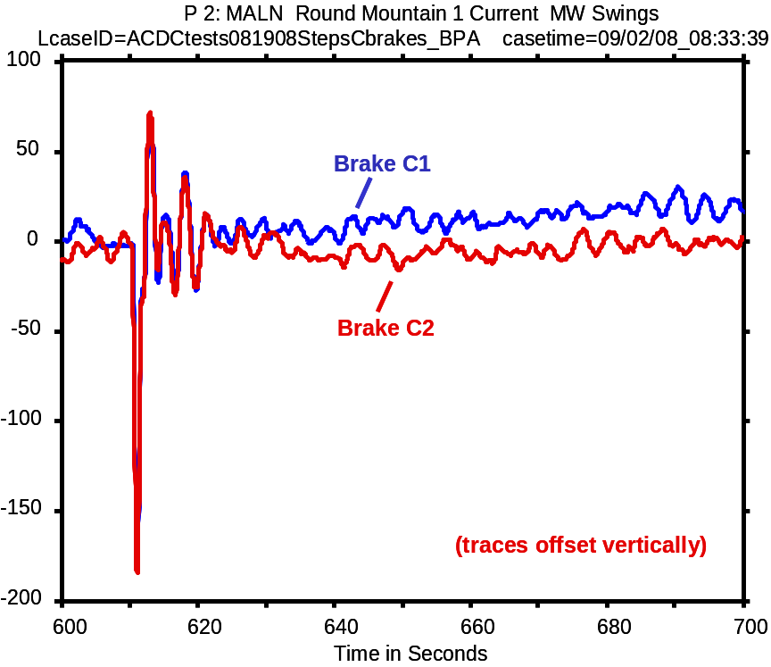
Fig. 7. Ringdown transients on 08/19/08 (extended view)
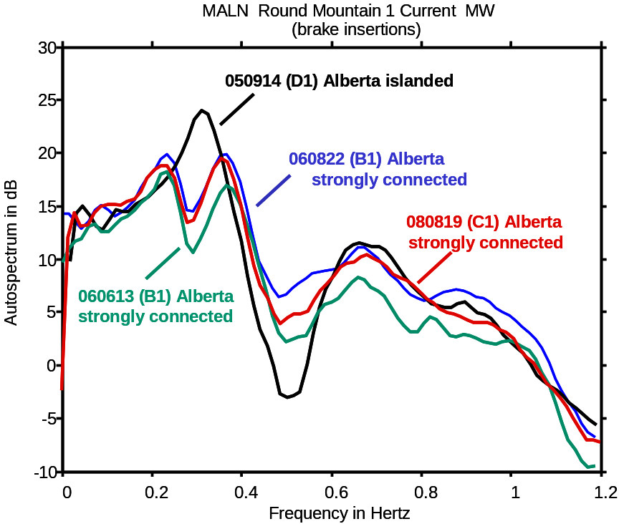
Fig. 8. Ringdown autospectra for test brake insertions, 2005-2008

Some Basic Aspects of Modal Analysis
Modal analysis of oscillatory dynamics builds upon a tentative assumption that the dynamics are essentially linear for small motions about the equilibrium state. To the extent that this assumption is valid, the "swings" following a brief disturbance will be a sum of modal response terms like
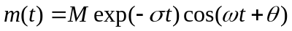 (1)
Here (σ, ω) are mode parameters that denote the frequency and damping of a mode, and (M, θ) are mode shape parameters (signal residues) that denote the strength and phase of that mode within signal m(t). Table 4 and Fig. 9 show the decomposition of a ringdown signal into four oscillatory modes.
Table 4. Modal components for ringdown signal in Fig. 9
Mode Freq in Hz Damping Ratio (%)
N-S 0.244 9.6
Alberta 0.363 9.2
Kemano 0.646 13.9
Colstrip 0.853 22.2

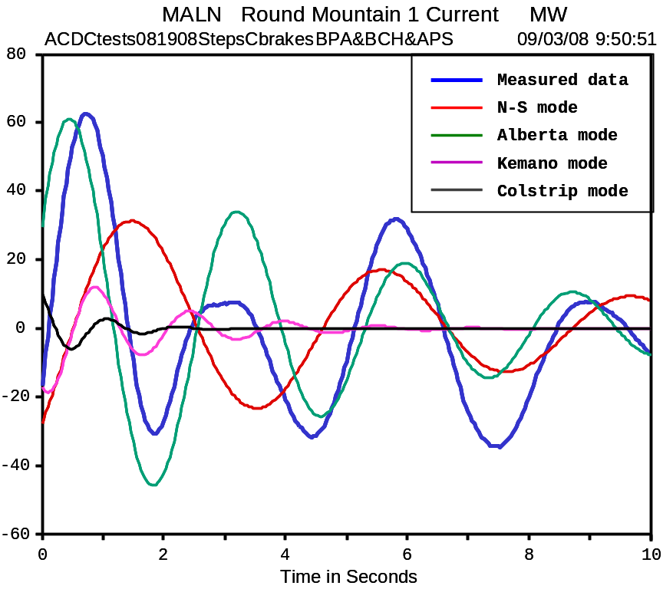
Fig. 9. Decomposition of a ringdown signal into four oscillatory modes
Mathematically, the mode parameters are expressed as a complex eigenvalue λ = σ+jω and the mode shape parameters are expressed as residues. The more specific term signal residue is sometimes applied to distinguish them from residues which appear in the eigenanalysis below.
Underlying equation (1) are the system equations =Ax+Bu and y=Cx+Du, where denotes differentiation of x with respect to time. Variables u and y are respectively the input and the output of the system; x, the internal state of the system, is usually taken to be a vector of n elements.
Full eigenanalysis is based upon modal decompositions of the A matrix, which in turn requires a source model from which to extract it. This produces a full set of eigenvalues plus associated eigenvectors. The eigenvalues lead to residue matrices with mode shape information that is specific to very special kinds of inputs and outputs.
Prony analysis, by contrast, is based upon modal decompositions of output vector y(t). The modes and the modal parameters are those for a subset of A that is estimated from a subset of y(t); the mode shape parameters are specific to whatever stimulus may have produced the output. Given sufficient knowledge of u(t), an approximating subset can be constructed for {A,B,C.D} [,].
In practice u(t) is usually a sequence of discrete switching events that are not immediately known. Small signal analysis assumes that the response to each event is a free ringdown of form
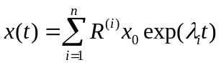 (2)
where R^{(i)} is a residue matrix and state x₀ is the deviation from final equilibrium. Most events will redefine x₀ , and some events or discrete control actions may significantly alter the underlying system parameters. Hence some kinds of analysis must proceed on a piecewise basis.
Prony analysis generally fits a tandem model to several measured components of y(t). One objective in this is to enhance the modal estimates. Another is to obtain an interaction pattern revealing how the activity of each mode is distributed across the signal set. An example of this is shown in the “compass plot” of Fig. 10, which displays the length and the angle of each signals residue for response of the Kemano mode to bake insertion B1 on August 22, 2006. The reader is cautioned that this mode shape is that for a signal y(t) responding to an initial offset state x₀. Mode shapes associated with direct eigenanalysis of the A matrix are not quite the same thing.

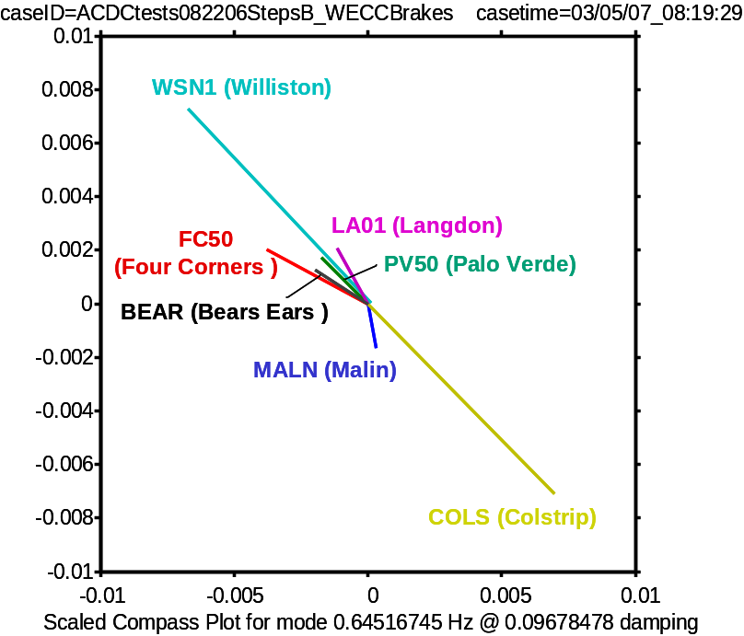
Fig. 10. Pattern for Kemano mode in WECC local frequency signals
Brake insertion B1, 08/22/06
Modal analysis methods are approximate, and none can generate results of higher quality than the information provided to them. Results from model-based eigenanalysis are colored by errors in the model, and by linear approximations to nonlinear phenomena such as saturation and dead zones. Results from measurement-based eigenanalysis are colored by the extent and quality of the available signals. Some modes may not be sufficiently observable within the signal set. Those which are observable may be obscured by noise, by dynamic nonlinearities, and by hidden inputs to the system.
Prony analysis, in the present context, is considered to include any algorithm that directly fits time domain signals with the "Prony model" of equation (1). This model generalizes that of Fourier analysis, and can sometimes be used for the same purposes. Fourier methods remain a mainstay of WAMS analysis, however.
General indications for modal frequencies can be obtained by Fourier analysis of random variations in power system quantities, under ambient (that is, undisturbed) conditions. Fig. 11 shows typical results for real power on the Malin-Round Mountain line. Note that the major peaks in Fig. 11 align with those of Fig. 8, and that the strength of the peaks change with power system conditions. Somewhat sharper results are obtained by correlation analysis of multiple signals.

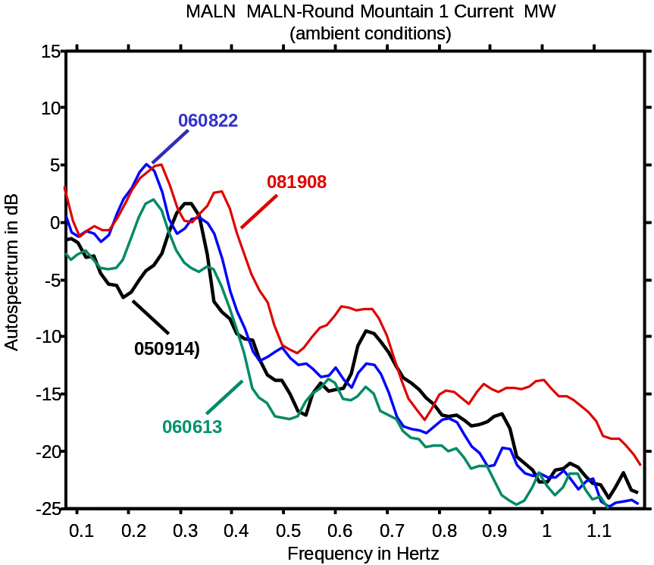
Fig. 11. Autospectra for random fluctuations on the Malin-Round Mountain line

Observability of Chief Joseph Brake Insertions
Insertions of the Chief Joseph dynamic brake are clearly observable across the entire power system. This is illustrated by the response summary of Fig. 12. The signals depicted were selected to provide an overall profile for the system, and they do not represent the entire collection of PMUs from which data were obtained.
Fig. 13 shows the response in each signal as beginning at the time of brake insertion. This demonstrates that the various phasor networks were operating in synchronism, and that such disturbances “propagate” across the grid with no appreciable time delays.
It should be noted that the frequencies in these figures are of type EFreqL_FD, whereas the local frequencies measured by the PMUs themselves are of type FreqL The prefix ‘E’ in the type tag indicates that the frequency has been estimated from the bus angle, and the postfix ‘_FD’ indicates that the estimation logic is based upon forward difference calculations. This substitution assures that all frequencies are calculated in the same manner, and it often enhances quality of the data.
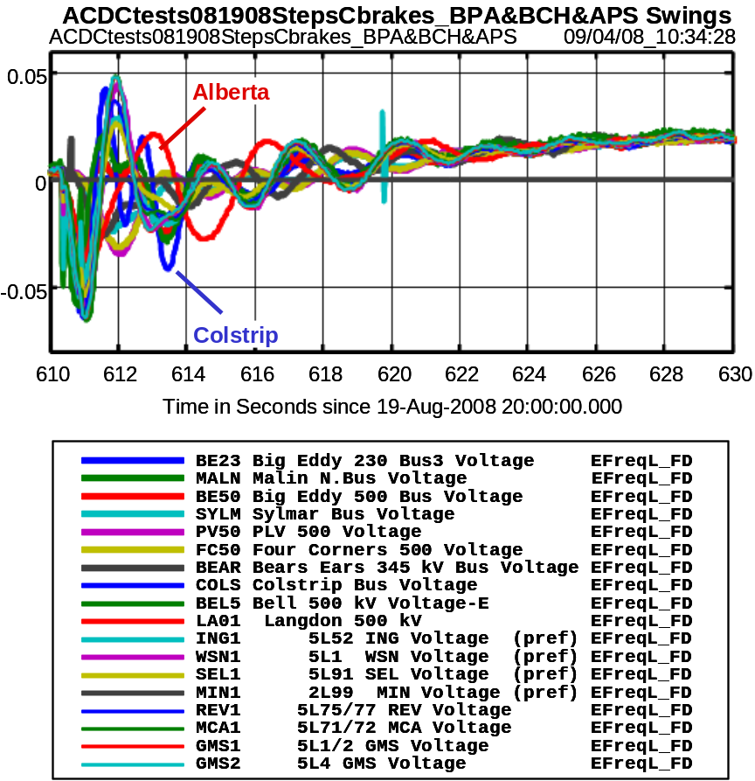
Fig. 12. Frequency swings for Brake Insertion Event C1, 081908
(frequencies estimated as forward difference of bus angle signals)
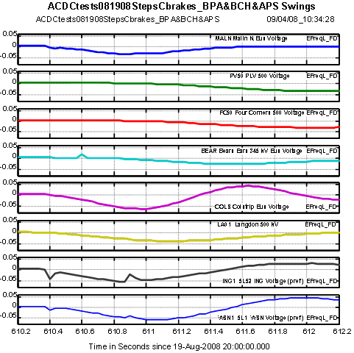
Fig. 13. Timing Checks: Brake Insertion Event C1, 081908
(frequencies estimated as forward difference of bus angle signals)

Observability of Random Probing Signals
The basic strategy in low level probing is to start with a very weak probing signal, and to progressively adjust that signal to the minimum level that produces acceptable results. Key real-time resources for this are PDC StreamReaders, accompanied by an add-on Dynamic Signal Analyzer (DSA) tool for spectral analysis (shown in Section 15.0). Many of these same functionalities are being incorporated into the PNNL ModeMeter and the Real Time Dynamic Monitoring System (RTDMS) [Error: Reference source not found]. Off line tools for full analysis include SYSFIT [], for transfer function fitting, plus a range of advanced tools that are applied in time domain [,,].
The probing tests of 2005 through 2008 establish that good results can be obtained with band limited white noise having limits on the order of ±20 MW dc and a standard deviation of 14 MW. This probing signal roughly doubles the apparent noise that is natural to the power system, and is essentially invisible to all but the closest examination. Typical waveforms for the tests in August 2008 are shown in Fig. 14. Fig. 15 shows gain response for bandpass filter BP1, which is used in much of the analysis reported here. Fig. 16 and Fig. 17 show the effects of filter BP1 upon signal waveforms, and Fig. 18 shows that spectra are not significantly changed across the frequency range of interest.
The general observability of random noise probing depends quite strongly upon the means that are used to examine power system activity. This is illustrated by Fig. 17 and ***, together with a series of related examples.
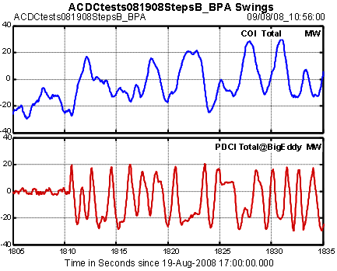
Fig. 14. Startup of ±20 MW noise modulation, test step B2 on August 19, 2008
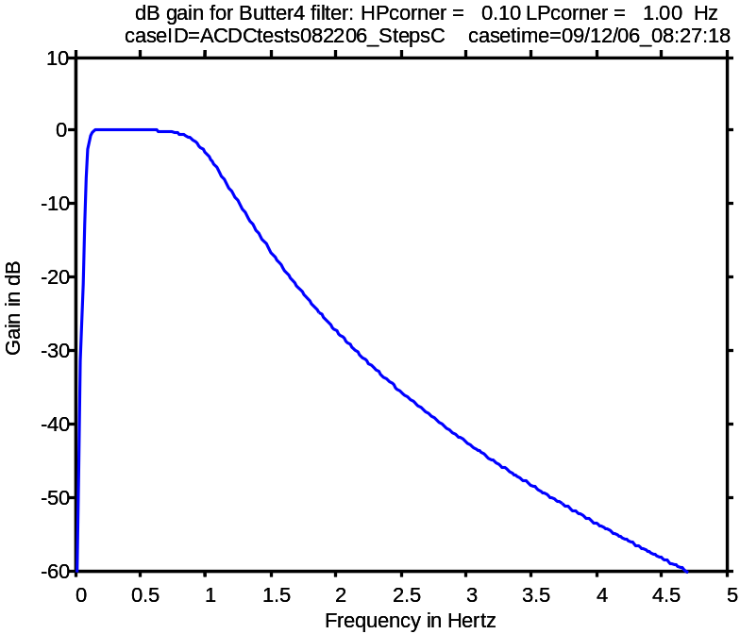
Fig. 15. Bandpass filter BP1 (set to [0.08 1.0] Hz)
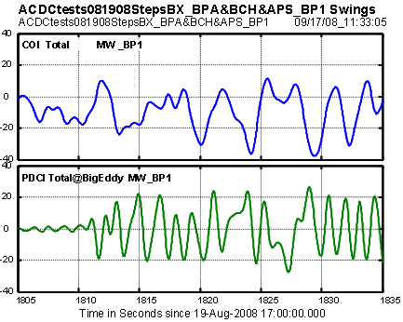
Fig. 16. Startup of ±20 MW noise modulation, test step B2 on August 19, 2008
(Signals have been filtered with BP1)
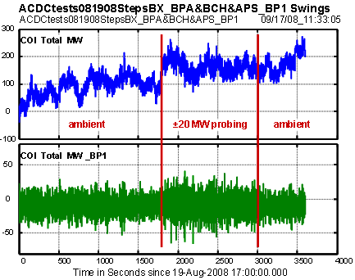
Fig. 17. Filter effects on COI MW signals
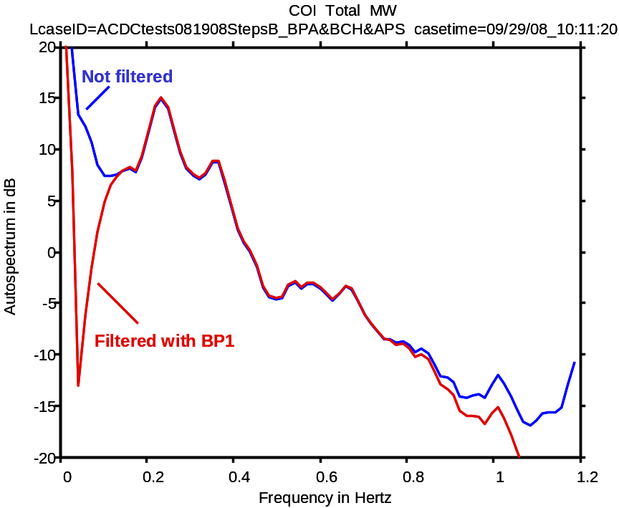
Fig. 18. Autospectrum for fluctuations in COI Total MW, ambient conditions of step B1
(raw vs. filtered data)
Fig. 19, which is based upon the bandpassed data, shows that the variation in total COI MW is 11.01 MW during the ambient conditions of test step B1. Applying ±20 MW probing during test step B2 increases the variation to 13.81 MW, which is scarcely noticeable to ordinary observations.
Fig. 20 shows a histogram for the probing signal obtained by PDCI modulation. The range of the raw data is close to ±20 MW, with a standard deviation of 15.10 MW. Filtering the data with BP1 extends the range to ±32 MW, with a standard deviation of 14.01MW.
Fig. 21 provides a frequency domain view of the effects that ±20 MW noise probing has upon random variations in COI MW. Activity in the N-S mode is almost unchanged; the broadened peak suggests that the frequency of this mode may have shifted during the probing interval. The increase in spectral levels is about 4 dB for the Alberta mode, and substantially higher than that for modes above that. Though modest, such changes in spectral levels are fairly apparent in spectral waterfalls.
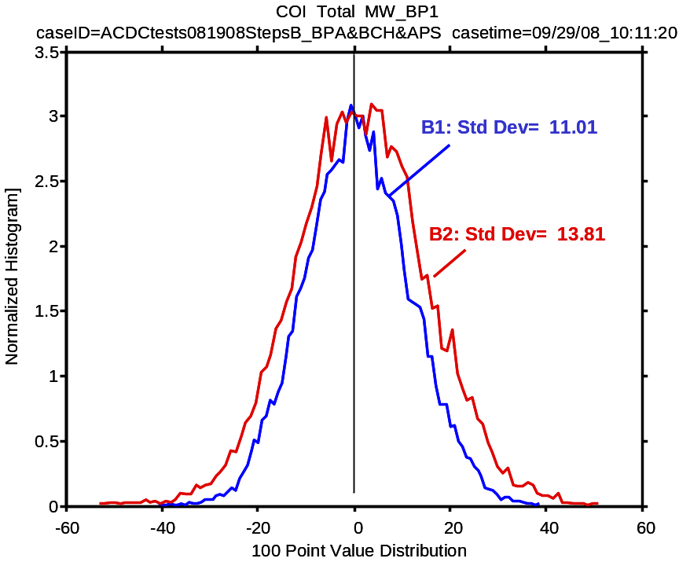
Fig. 19. Histograms for activity in COI total MW
(BP filtered data, without and with ±20 MW probing)
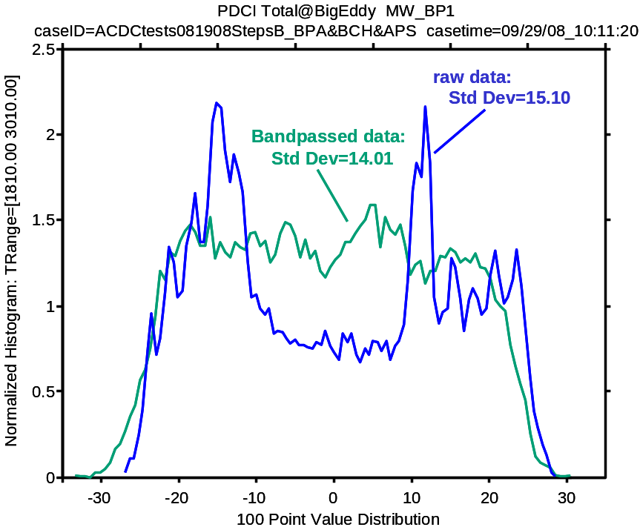
Fig. 20. Histogram for PDCI variations during ±20 MW noise probing (B2)
(raw vs. filtered data)
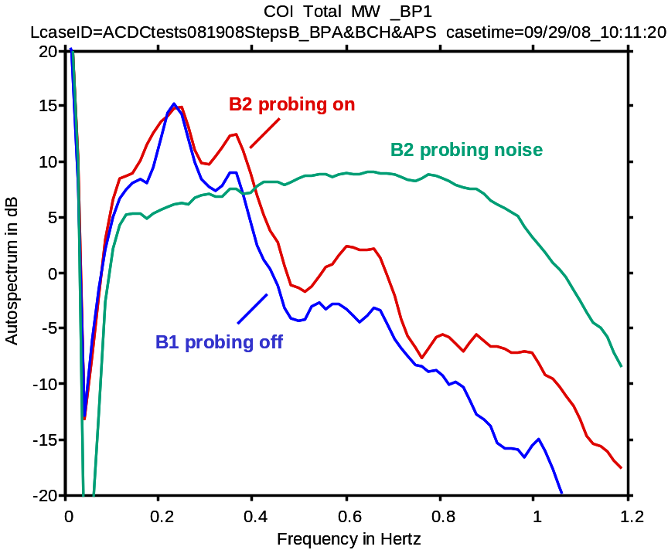
Fig. 21. Autospectra for activity in COI MW
(filtered data, with and without ±20 MW probing)

[continue here]

Ambient Correlation Signatures
Correlation analysis provides various measures of the way in which the activity in other signals relate to the activity in a selected reference signal [Error: Reference source not found,Error: Reference source not found]. The results shown in this section are based upon Test step B1 on August 19, 2008, and generally use MW swings on Malin-Round Mountain circuit 1 as the reference signal. The results are very similar to those of step C1 on August 22, 2006.
Fig. 22 shows that MW swings on Custer-Ingledow circuit 1 are strongly coherent with those at Malin for the North-South mode and for several modes above 0.5 Hz. Coherency is small for the Alberta mode (near 0.38 Hz). The corresponding autospectra show a peak in that region for Malin-Round Mountain activity, but not for Custer-Ingledow activity.
Fig. 23 through Fig. 25 show similar results for other interchange signals that, when combined with those at Malin and Ingledow, provide a good basic summary of modal signatures. However, for a sharper view of modes above 0.5 Hz, it is highly desirable to include signals that have recently become available in western Canada (BCH and the Alberta ISO). Fig. 26 through Fig. 28 demonstrate this, and the general issue is given special attention in [Error: Reference source not found].
While Fig. 22 shows little evidence of the Alberta mode on Custer-Ingledow circuits, Fig. 26 does show such activity on Williston-Kelly Lake circuits. Fig. 27 and Fig. 28 show that the associated interaction path is predominantly east-west, along the Selkirk-Cranbrook-Langdon connection. These figures also show strong interactions of the North-South mode along this path.

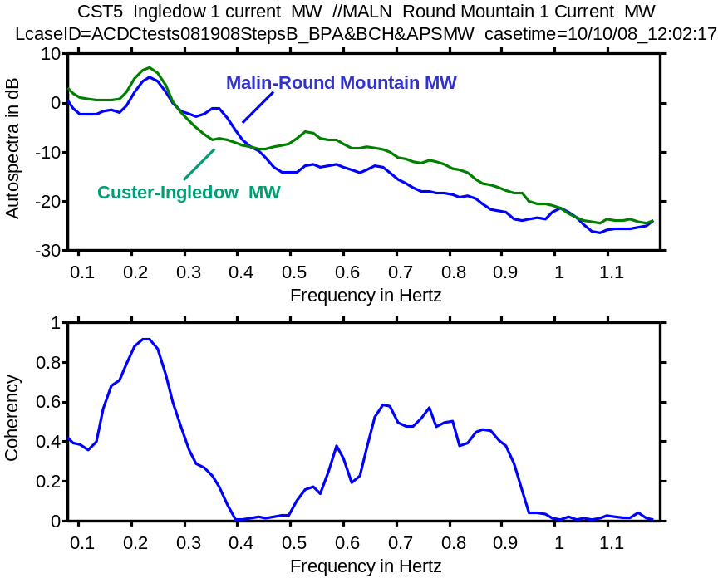
Fig. 22. Ambient correlations: Custer-Ingledow vs. Malin-Round Mountain
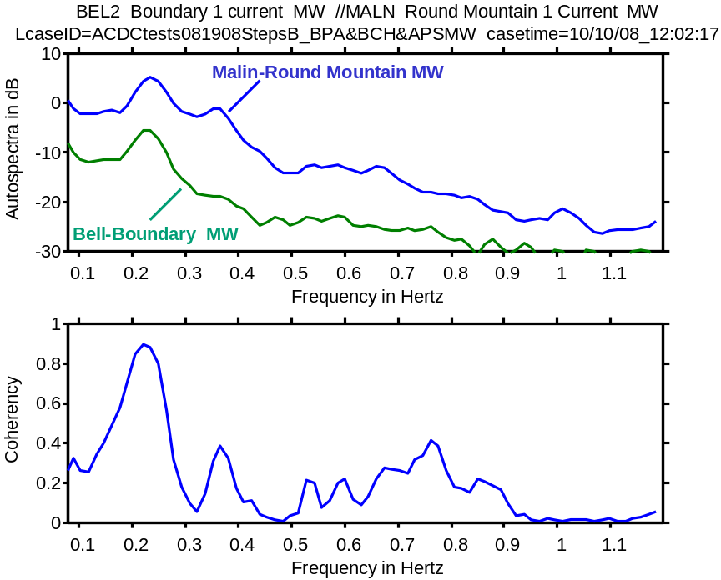
Fig. 23. Ambient correlations: Bell2-Boundary vs. Malin-Round Mountain
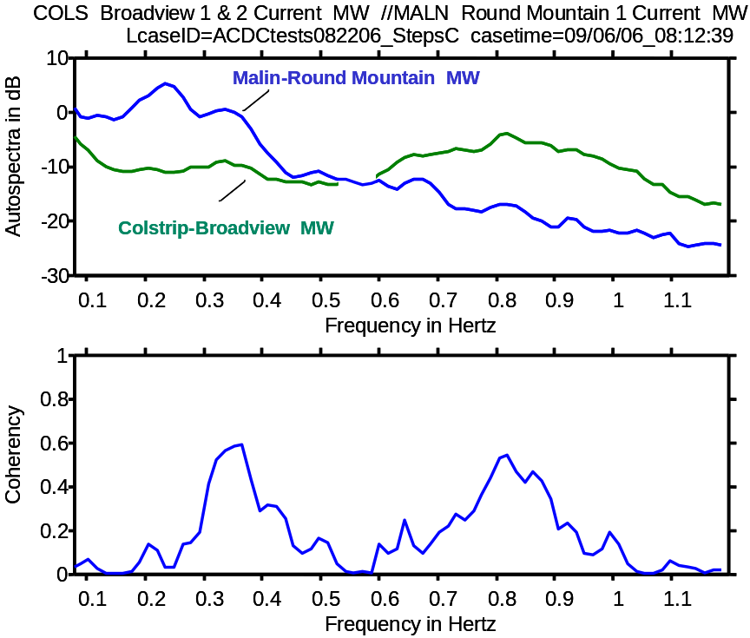
Fig. 24. Ambient correlations: Colstrip-Broadview vs. Malin-Round Mountain
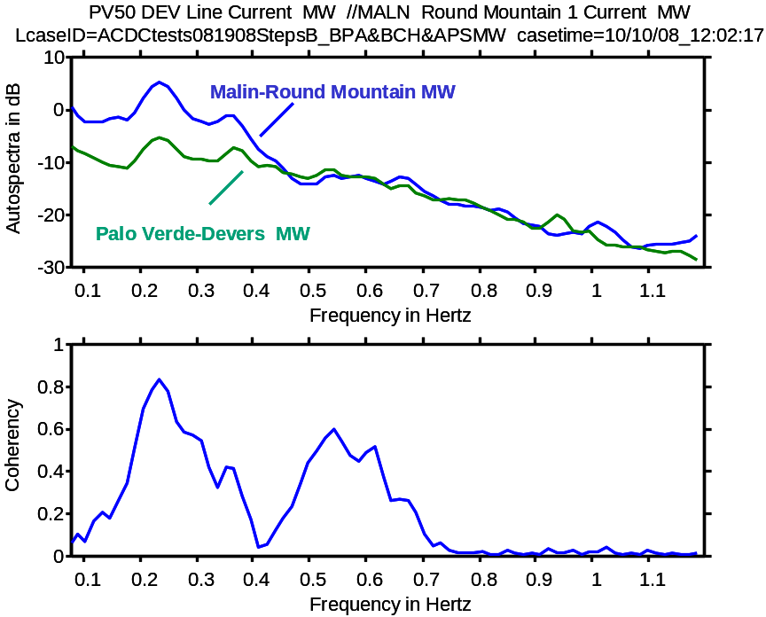
Fig. 25. Ambient correlations: Palo Verde-Devers vs. Malin-Round Mountain
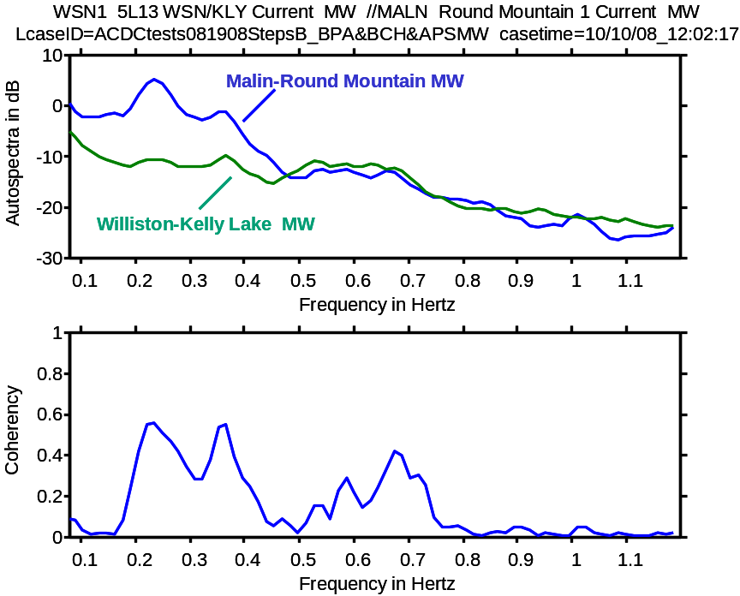
Fig. 26. Ambient correlations: Williston-Kelly Lake vs. Malin-Round Mountain
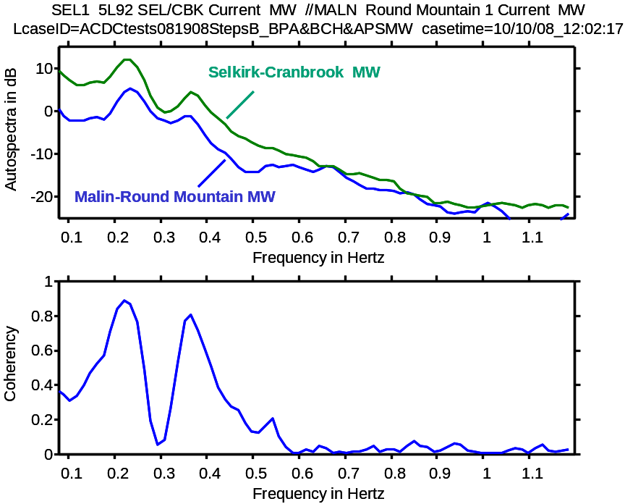
Fig. 27. Ambient correlations: Selkirk-Cranbrook vs. Malin-Round Mountain
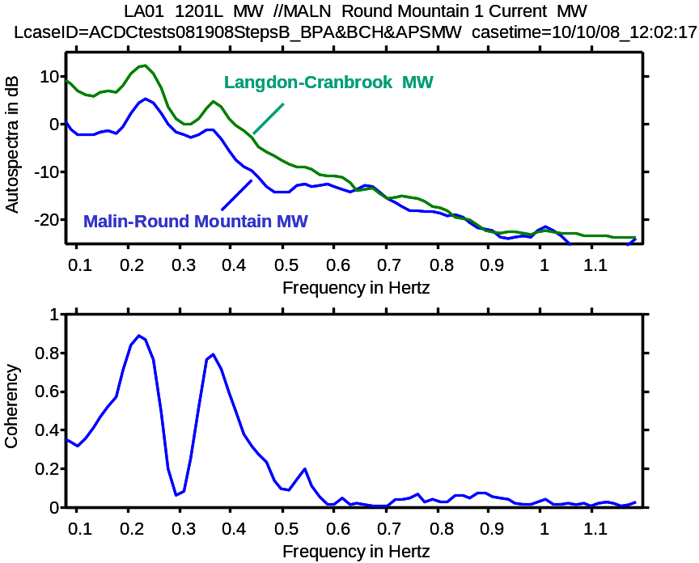
Fig. 28. Ambient correlations: Langdon-Cranbrook vs. Malin-Round Mountain

Correlation Analysis for HVDC Probing with Low Level Noise
Correlation analysis can also provide useful transfer function data showing how the activity in one signal is related to the activity in a selected reference signal. Fig. 29 and Fig. 30 show this for the response of total COI MW to ±20 MW PDCI probing noise, during test step B2 on 08/19/08.
The gain data in Fig. 30 show that response on the COI circuits is chiefly associated with the N-S and the Alberta modes. Unlike the response for step C2 on 08/22/06, the associated phase data shows no abrupt steps suggesting a transfer function zero close to the imaginary axis.
Analytical models can be extracted directly from the transfer function data, either by direct model fitting or by Prony analysis of the transfer function’s time domain inverse. A later section will show preliminary results for extracting models from the signals themselves.
Fig. 31 through Fig. 35 show additional transfer functions for ±20 MW PDCI probing noise during test step B2. These are provided as examples to show that different lines can produce rather different transfer functions, and that a mode which is highly responsive in one signal may be nearly invisible in another.
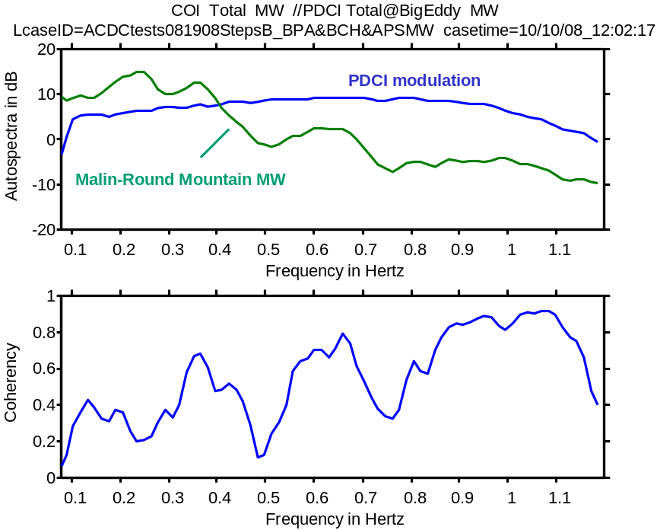
Fig. 29. Response correlations: Malin-Round Mountain vs. ±20 MW PDCI probing noise
step B2 on 08/19/08
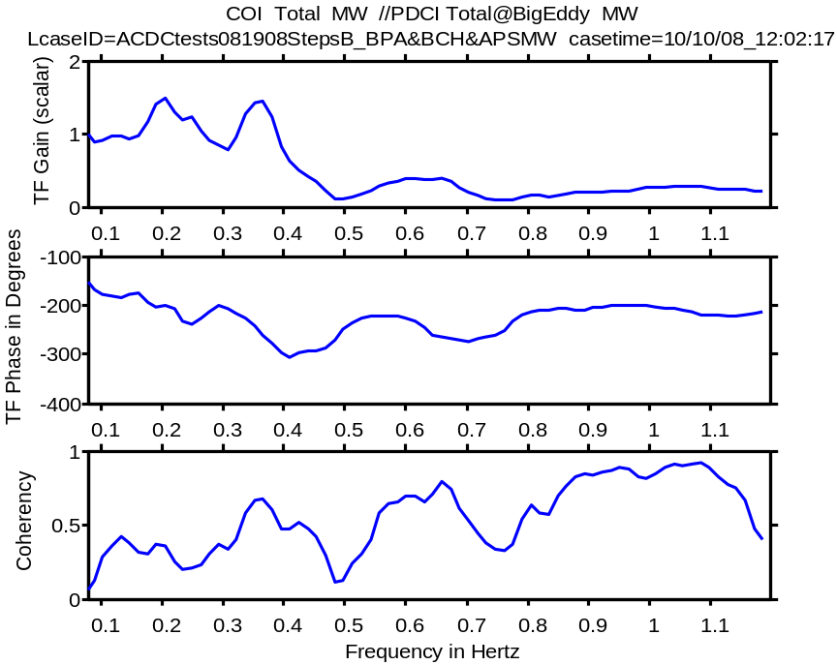
Fig. 30. Transfer function for Malin-Round Mountain MW vs. ±20 MW PDCI probing noise
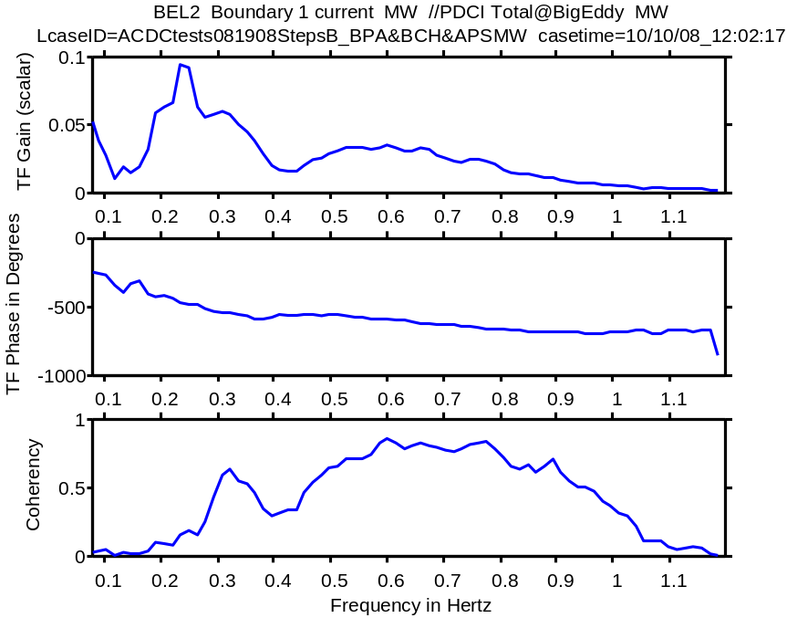
Fig. 31. Transfer function for Bell2-Boundary MW vs. ±20 MW PDCI probing noise
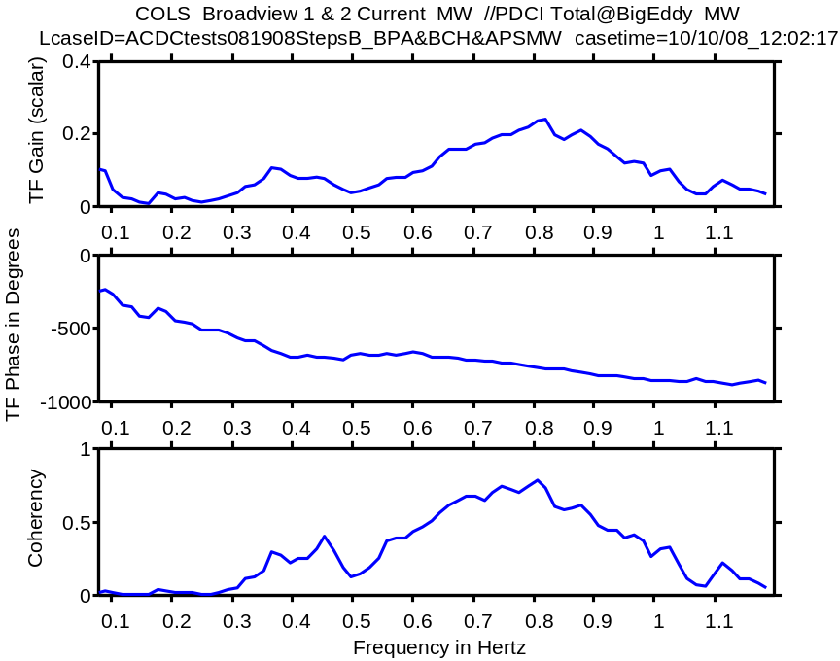
Fig. 32. Transfer function for Colstrip-Broadview MW vs. ±20 MW PDCI probing noise
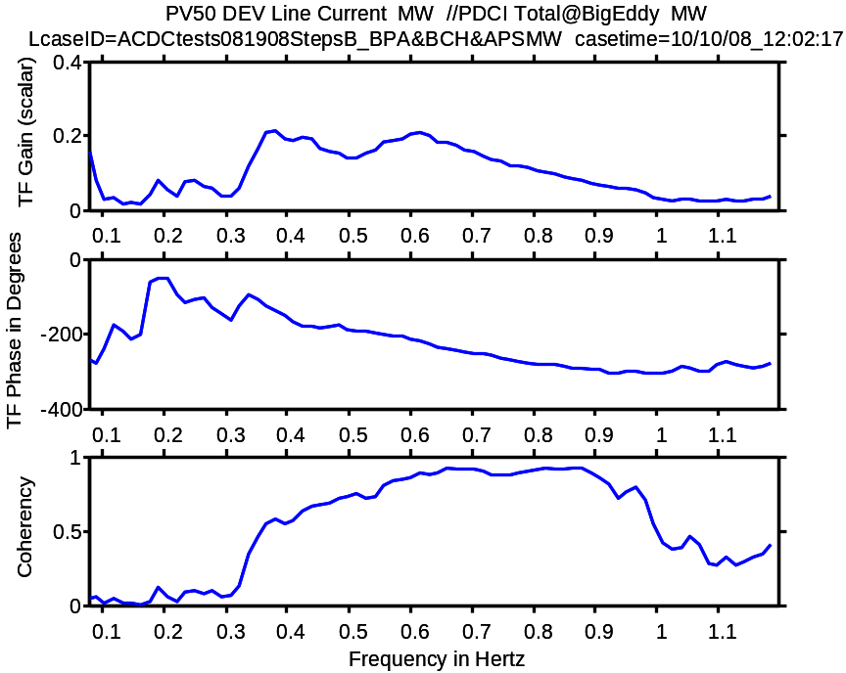
Fig. 33. Transfer function for Palo Verde-Devers MW vs. ±20 MW PDCI probing noise
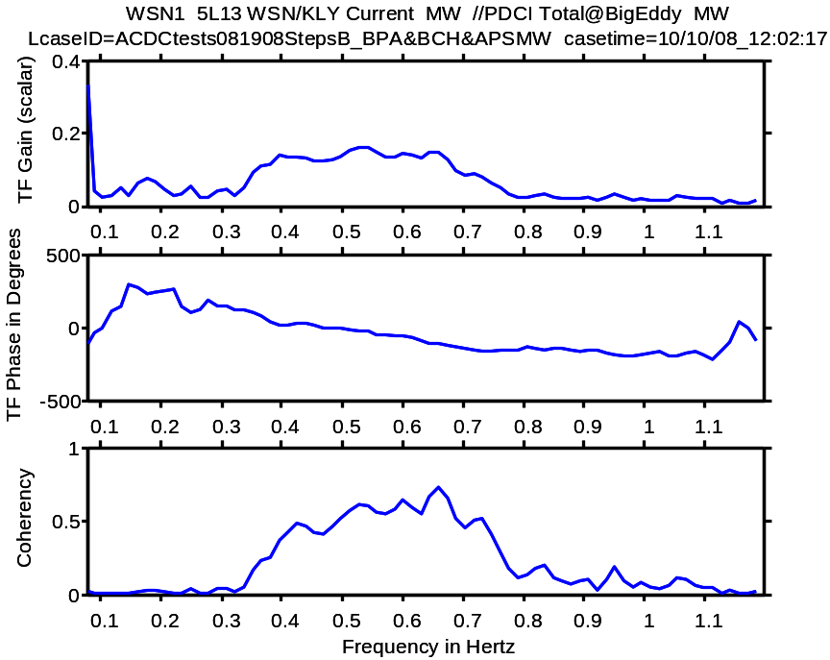
Fig. 34. Transfer function for Williston-Kelly Lake MW vs. ±20 MW PDCI probing noise

Fig. 35. Transfer function for Langdon-Cranbrook MW vs. ±20 MW PDCI probing noise

Transfer Functions for PDCI Terminal Response to Low Level Modulation
The transfer functions shown in Fig. 36 show that PDCI angles (and therefore frequencies) contain much the same dynamic information as do COI MW and other more remote signals. This is important when PDCI modulation tests are supervised at the terminal where the test signals are applied, and it has potential applications to HVDC damping controls.

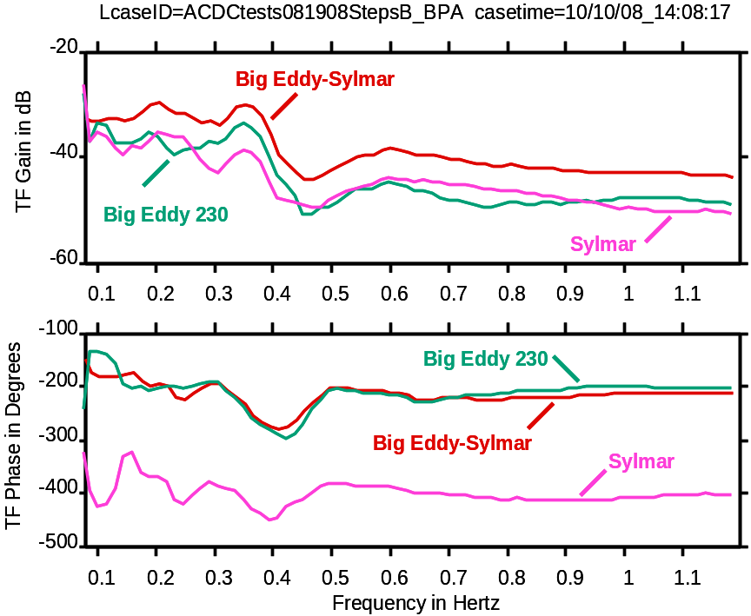
Fig. 36. Transfer function for PDCI terminal angles vs. ±20 MW PDCI probing noise

Prony Analysis of Brake Insertion on C1 on August 19, 2008
This section provides a detailed modal analysis of brake insertion C1 on August 19, 2008. The key tool for this is Prony analysis via the DSI Toolbox. Fourier analysis is, as usual, used to select the signals for analysis and to assess quality of the fitted Prony models.
The methodology and many of the results resemble those detailed in [Error: Reference source not found]. Further details concerning the analysis procedure are available in [,] and in various application examples that are distributed with the DSI Toolbox.
The appropriate signals and methodology for modal analysis depend upon the nature of the event, the signals that are available, and the information to be extracted from them. The Introduction listed the following “information targets” for modal analysis:
a) Mode parameters
b) Mode shape
c) Interaction paths
d) Response to control
General analysis usually begins with a first estimate of interarea mode parameters. This is usually done with a fairly small collection of signals that, overall, provide a good overview of interarea modes. Line MW are usually selected as a starting point for this, partly for historical reasons (comparative data for earlier events is abundant) but also because they are a sensitive indicator of generator accelerating power. Care must be taken to avoid data that are significantly impacted by secondary control actions, however.
Mode shapes are usually determined from bus angles and frequencies across wide regions of the power system. These signals are sometimes made relative to some selected reference, such as the Sylmar 230 KV bus in the Los Angeles basin. The analyst should be aware that signals for estimated frequency are more reliable those produced at PMU level, and that modes which are coherent within some region of the power system may not be very observable within relative signals for that region.
Interaction paths are usually determined from MW signals on key lines, and sometimes from MVar or other signals associated with major control systems. The analysis procedure is similar to that for mode shapes, but the context is more oriented to the equipment level.
Response to control is determined as an extension of interaction path analysis. The chief differences are that there is a known controlled input to the power system, and that the design of this input is important for testing the system and, perhaps, for enhancing system dynamic performance.
The remainder of this section uses increasingly large signal collections to address information targets (a) through (c) in turn. This is typical for major system events, where the scope of analysis expands as additional data become available and interim results guide the direction of inquiry. The analysis begins with signals which are immediately available on BPA’s PDC.
The timing for Prony analysis is usually determined by inspecting the transient ringdown in COI MW signals. Fig. 37 and Fig. 38 are typical. The transient usually merges into the ambient noise level within some 20 seconds, and it is important that the Prony analysis not continue beyond that time.
It is also important that the Prony analysis start after the brake has been disconnected, and long enough after that for saturation or other nonlinear effects to be unlikely. A general guideline for this is shown in Fig. 37 , where A and B approximate the first two times when the transient crosses the mean value of the post-disturbance signal.
A first analysis would usually start at A and last for 14 seconds – in Matlab notation, the analysis interval is A+[0 14]=[tstart tstop1] seconds. Then, as a check on nonlinearities and hidden inputs, analyses are also performed on the intervals A+[0 12]=[tstart tstop2], [B tstop1], and [B tstop2]. If results are not consistent then it becomes necessary to examine voltage magnitudes and other signals for evidence of control actions during the ringdown, and to base the analysis on signals which are remote from the suspected problem. Modal damping for the August 19 tests was extremel;y high, however, and best results were found with a processing interval of just 10 seconds.
A few important signals usually merge into the ambient noise rather quickly. The Colstrip MW signal is a leading case of this, and the analysis interval is usually set at A+[0 6] seconds.
[expand discussion & examples]

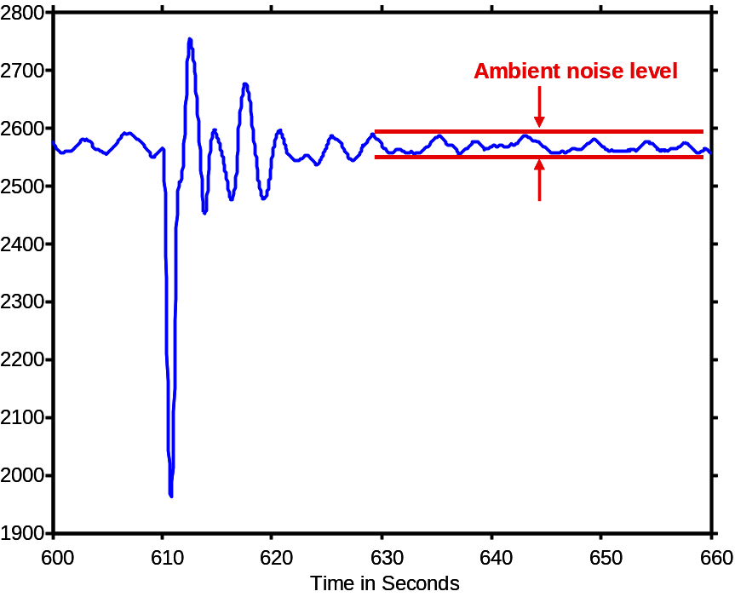
Fig. 37. Merging of transient ringdown into ambient noise
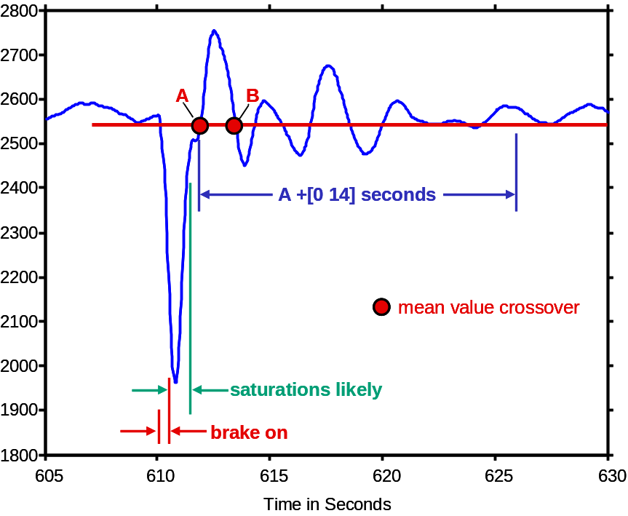
Fig. 38. Analysis timing for brake event ringdown

Modal Analysis of Ringdown Signals for Brake Insertions [update this section]
A basic set of BPA signals for determination of modal parameters is shown in Fig. 39. Power flowing on the Devers-Palo Verde line is sometimes added to this basic set. However, the associated voltage signals often indicate that some discrete control action has occurred nearby, and the data received from SCE is prone to communication problems.
Spectral signatures for these signals are shown in Fig. 40, where the dotted vertical lines are at frequencies for interarea modes as determined by Prony analysis.
Setup of the Prony tool (called the Ringdown GUI) is shown in Fig. 41. The analysis starts at 611.9 seconds after 22-Aug-2006 20:00:00.000 (1300 hrs. PST), and most signals are processed for 14 seconds. The Colstrip-Broadview signal is an exception to this; the transient fades into the ambient noise level quite rapidly, so only the first 6 seconds is included in the analysis.
Basic Prony Solution (PRS) results are shown graphically in Fig. 42, which displays the Results Screen for output signal 2. The selected modes provide a quite reasonable fit to the time domain record, and also to the amplitude and phase of its FFT equivalent.
Table 5 and Table 6 provide the results of this particular analysis in tabular form. The mode shape information contained in Table 6 can also be presented graphically. The use of this display is deferred until later portions of this section, where it is of more immediate interest.
Table 5: PRS results #1 for Brake Event B1 on 08/22/06– 4 BPA MW signals
Sorted Mode Table for MALN Round Mountain 1 Current MW
Pole Freq in Hz Damp Ratio (pu) Res Mag Res Angle
1 0.24457386 0.09650302 42.97790323 -125.37057786
3 0.37325895 0.08149476 68.49721288 -72.72228997
5 0.64201579 0.09875745 16.14141450 125.19810557
7 0.83040170 0.10946506 18.97985859 -77.01778871
9 1.11656352 0.04238910 3.02749942 84.33755476
11 1.53552436 0.06452895 4.43331587 -167.53833977
13 1.79599955 0.04307541 0.91672141 133.96171028

Table 6. PRS results #2 for Brake Event B1 on 08/22/06 – 4 BPA MW signals
Sorted Mode Table for pole1: Interarea oscillation
Signal Freq in Hz Damp Ratio (pu) Res Mag Res Angle
MALN Round Mountain 1 Current MW 0.24457386 0.09650302 42.97790323 -125.37057786
COLS Broadview 1 & 2 Current MW 0.24457386 0.09650302 1.21022959 100.86639055
CST5 Ingledow 1 current MW 0.24457386 0.09650302 47.80477662 60.36275167
BEL2 Boundary 1 current MW 0.24457386 0.09650302 11.45821475 60.29963754

Sorted Mode Table for pole3: Interarea oscillation
Signal Freq in Hz Damp Ratio (pu) Res Mag Res Angle
MALN Round Mountain 1 Current MW 0.37325895 0.08149476 68.49721288 -72.72228997
COLS Broadview 1 & 2 Current MW 0.37325895 0.08149476 17.39058635 -72.00060141
CST5 Ingledow 1 current MW 0.37325895 0.08149476 9.33029729 -50.05551250
BEL2 Boundary 1 current MW 0.37325895 0.08149476 8.96498776 -56.42918534

Sorted Mode Table for pole5: Interarea oscillation
Signal Freq in Hz Damp Ratio (pu) Res Mag Res Angle
MALN Round Mountain 1 Current MW 0.64201579 0.09875745 16.14141450 125.19810557
COLS Broadview 1 & 2 Current MW 0.64201579 0.09875745 38.88079850 148.48926522
CST5 Ingledow 1 current MW 0.64201579 0.09875745 67.63853435 145.29027330
BEL2 Boundary 1 current MW 0.64201579 0.09875745 8.12245478 144.16787447

Sorted Mode Table for pole7: Interarea oscillation
Signal Freq in Hz Damp Ratio (pu) Res Mag Res Angle
MALN Round Mountain 1 Current MW 0.83040170 0.10946506 18.97985859 -77.01778871
COLS Broadview 1 & 2 Current MW 0.83040170 0.10946506 83.80291035 36.01057180
CST5 Ingledow 1 current MW 0.83040170 0.10946506 26.27893330 -106.27017852
BEL2 Boundary 1 current MW 0.83040170 0.10946506 1.93913847 -110.75277817

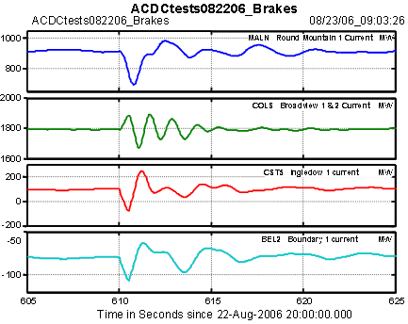
Fig. 39. BPA line MW signals for initial Prony analysis of Brake Event B1, 082206
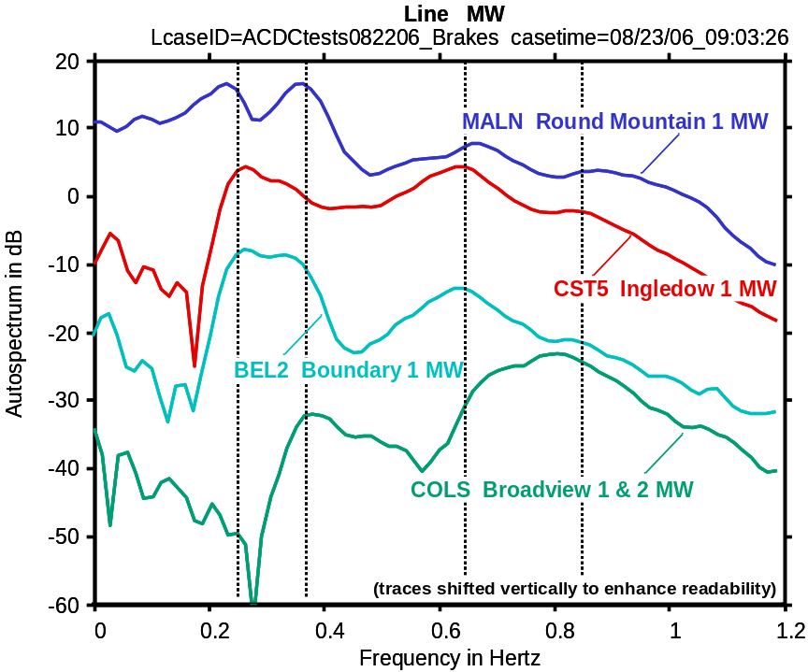
Fig. 40. Signatures of BPA line MW for initial Prony analysis of Brake Event B1, 082206
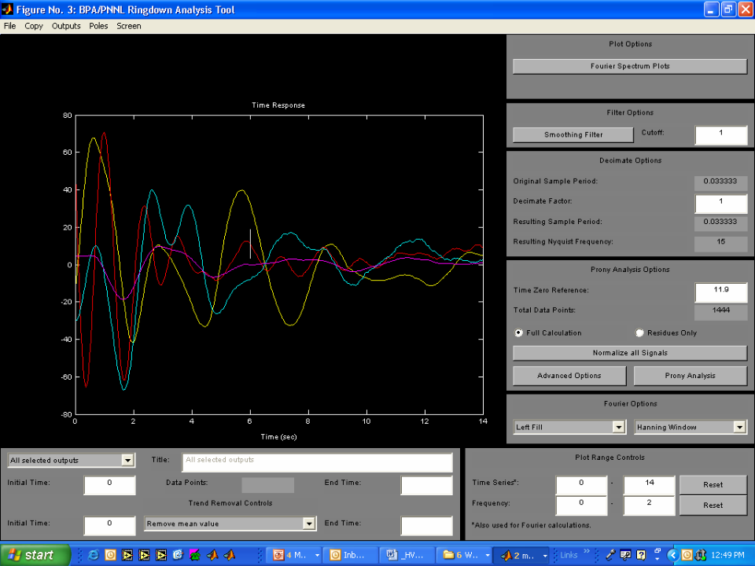
Fig. 41. Ringdown setup for Prony analysis of Brake Event B1, 082206

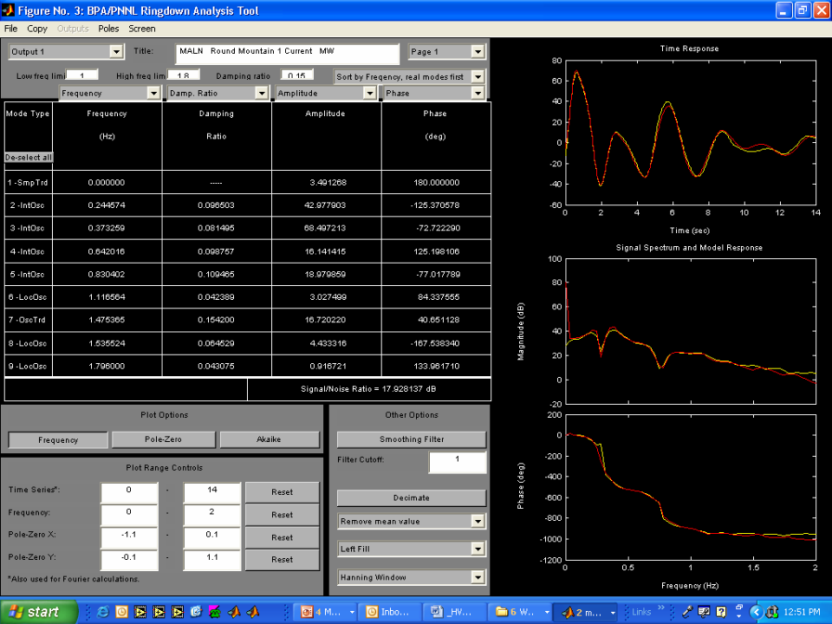
Fig. 42. Partial results for Prony analysis of Brake Event B1, 082206

Integrated Modal Analysis of Ringdown Signals for the Western Interconnection
This subsection extends ringdown analysis to the entire western interconnection. The primary objective is to determine mode shapes, both as “signature” information and as a step toward identifying the participation of particular plants in the associated modes.
A first issue in modeshape analysis is to determine appropriate signals for analysis. By choice, one would use local bus frequencies. But, as mentioned earlier, “one sided” disturbances such as a brake insertion (or a generator trip) produce a frequency dip followed by a slow exponential recovery. The transient in Fig. 43 is typical in this regard. The exponential terms associated with frequency recovery usually reduce the accuracy of Prony analysis.
Fig. 44 shows a useful set of line MW signals for estimating modal parameters and interaction paths. Results are shown in Table 7 plus Fig. 45 through Fig. 48. Mode shape results for frequencies and relative angles will be provided in later versions of this Report.
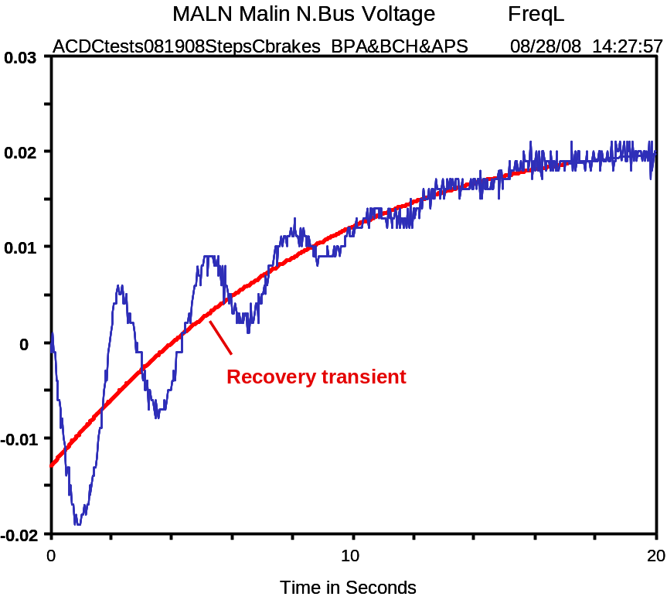
Fig. 43. Exponential transient in frequency recovery after brake insertion C1

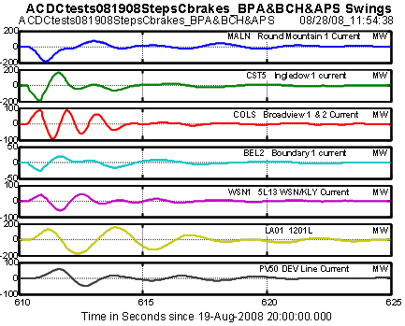
Fig. 44. Signal set A for wide area Prony analysis
Table 7. PRS results for Brake Event C1 on 08/19/08 – 7 line MW signals (TRange=[612.3 622.3])

Signal Freq in Hz Damp Ratio (pu) Res Mag Res Angle
MALN Round Mountain 1 Current MW 0.24660169 0.09735930 40.27757008 -138.42419562
CST5 Ingledow 1 current MW 0.24660169 0.09735930 48.16624603 46.54435272
COLS Broadview 1 & 2 Current MW 0.24660169 0.09735930 1.86777773 19.36671429
BEL2 Boundary 1 current MW 0.24660169 0.09735930 10.81920672 47.43308208
WSN1 5L13 WSN/KLY Current MW 0.24660169 0.09735930 3.22118039 -118.16602815
LA01 1201L MW 0.24660169 0.09735930 78.12707051 -125.69336216
PV50 DEV Line Current MW 0.24660169 0.09735930 11.33824895 48.73510923

Signal Freq in Hz Damp Ratio (pu) Res Mag Res Angle
MALN Round Mountain 1 Current MW 0.36272829 0.09293383 69.17894441 -64.39121003
CST5 Ingledow 1 current MW 0.36272829 0.09293383 5.45297235 135.65753313
COLS Broadview 1 & 2 Current MW 0.36272829 0.09293383 18.22457087 -71.19764563
BEL2 Boundary 1 current MW 0.36272829 0.09293383 5.90362515 -55.91167540
WSN1 5L13 WSN/KLY Current MW 0.36272829 0.09293383 19.34501084 -46.84293030
LA01 1201L MW 0.36272829 0.09293383 149.91089762 136.34980975
PV50 DEV Line Current MW 0.36272829 0.09293383 36.43266652 136.08568880

Signal Freq in Hz Damp Ratio (pu) Res Mag Res Angle
MALN Round Mountain 1 Current MW 0.62861443 0.13308578 17.15869579 174.13846681
CST5 Ingledow 1 current MW 0.62861443 0.13308578 50.45048919 152.71660038
COLS Broadview 1 & 2 Current MW 0.62861443 0.13308578 26.68462218 176.47310062
BEL2 Boundary 1 current MW 0.62861443 0.13308578 6.08700037 160.76265116
WSN1 5L13 WSN/KLY Current MW 0.62861443 0.13308578 39.32152258 -33.29675888
LA01 1201L MW 0.62861443 0.13308578 9.97750695 86.59401301
PV50 DEV Line Current MW 0.62861443 0.13308578 10.56176850 80.14677280

MALN Round Mountain 1 Current MW 0.79064347 0.20463077 19.79424299 24.81474731
CST5 Ingledow 1 current MW 0.79064347 0.20463077 30.14280005 -177.81461189
COLS Broadview 1 & 2 Current MW 0.79064347 0.20463077 71.60348115 96.15874880
BEL2 Boundary 1 current MW 0.79064347 0.20463077 4.95768246 178.57898924
WSN1 5L13 WSN/KLY Current MW 0.79064347 0.20463077 17.19895340 157.87364322
LA01 1201L MW 0.79064347 0.20463077 35.57653380 -143.98978428
PV50 DEV Line Current MW 0.79064347 0.20463077 12.03309321 40.14429535

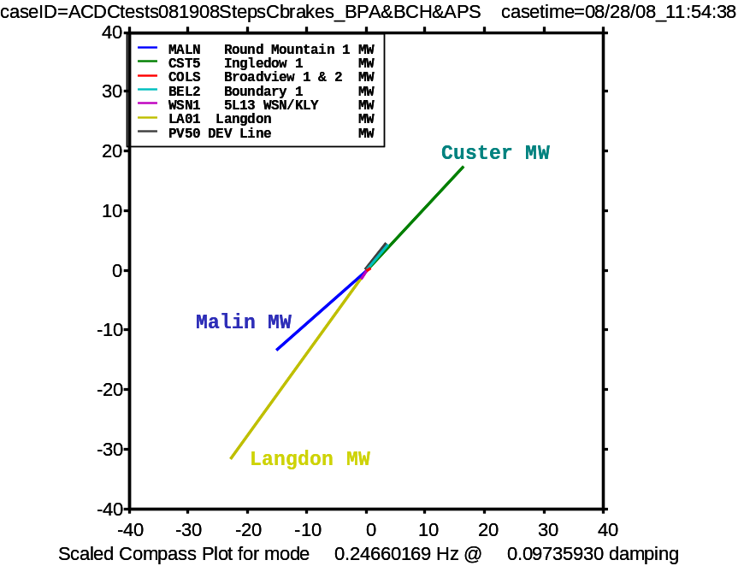
Fig. 45. Pattern for N-S mode in line MW signals
Brake insertion C1, 08/19/08

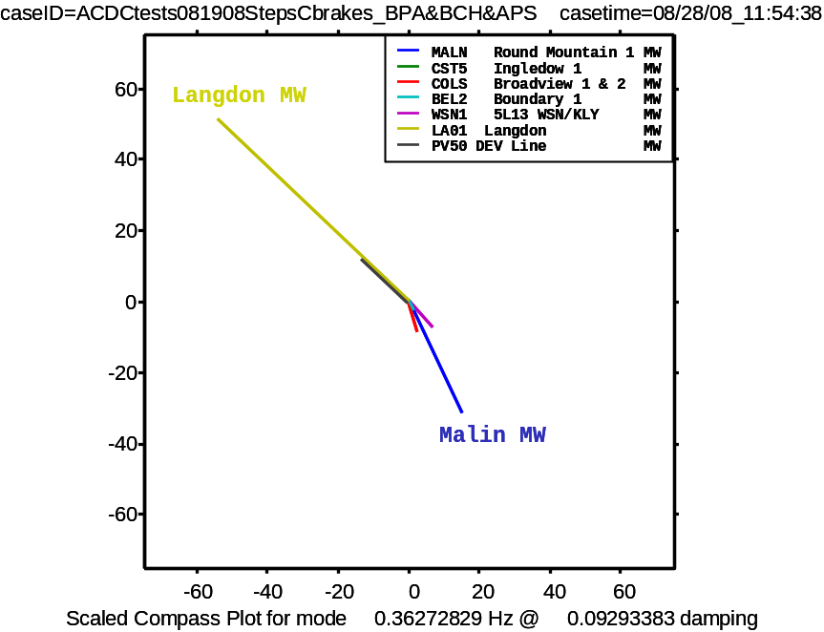
Fig. 46 Pattern for Alberta mode in line MW signals
Brake insertion C1, 08/19/08

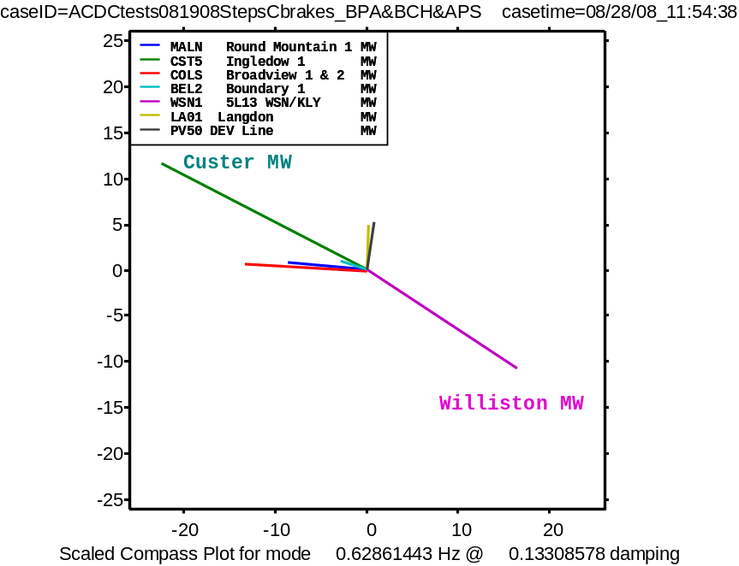
Fig. 47. Pattern for Kemano mode in line MW signals
Brake insertion C1, 08/19/08
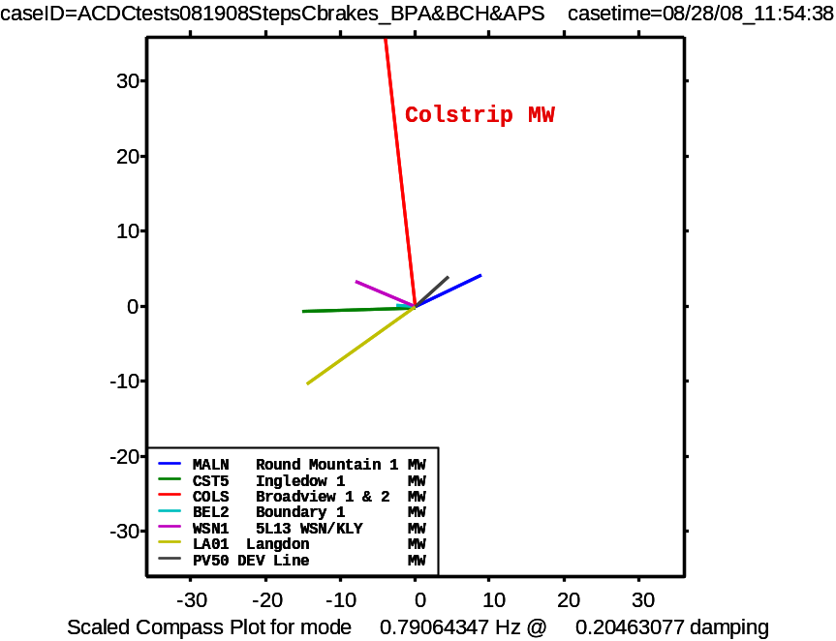
Fig. 48. Pattern for Colstrip mode in line MW signals
Brake insertion C1, 08/19/08

Discussion of Ringdown Results
Prony analysis for brake insertions C1 and C2 produced similar results for a variety of signal combinations. Fig. 49 and Fig. 50 show that the underlying “trends” for these two events are not quite the same, however. These differences affect the modal estimates, and they are a major consideration in selecting the best data for reliable analysis.
The customary search for “hidden inputs” during the ringdowns has, as yet, not produced a cause for the different trends. Review of those few SVC signals that are collected on the WAMS backbone produced a few small differences, such as that shown in Fig. 51 for the Langdon SVC. This suggests that hidden inputs, if any, may be associated with a prime mover, or perhaps AGC.
Fig. 49. Ringdown transients in Malin MW on 08/19/08 (extended view)
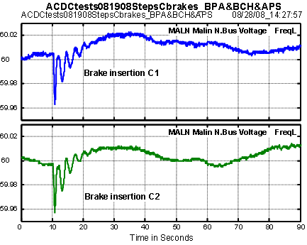
Fig. 50. Frequency recovery for Brake Events C1 & C2
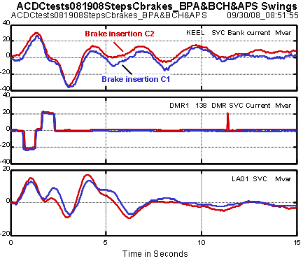
Fig. 51. SVC responses for Brake Events C1 & C2

Cross Validation of Recording Devices
The WECC WAMS has a primary backbone of synchronized phasor measurement units (PMUs) that continuously stream data to Phasor Data Concentrators (PDCs) at central locations for integration, recording, and further distribution. In addition to a range of other recording devices, the WECC WAMS also employs a variety of Portable Power System Monitor (PPSM) units as a secondary backbone to continuously record point-on-wave or analog transducer signals on a local basis. Though most of these recorders are GPS synchronized, any in depth analysis should be prefaced by a cross validation of recorder timing and response.

Cross Validation of PDC Records
Fig. 13 in Section 7.0 demonstrates the general observation that all PMUs in the WECC WAMS were well synchronized during the tests. Despite this, processing differences between PMUs of different types—or by PMUs of the same type but with different software editions—can produce small inconsistencies in the phasor measurements that become apparent under very close examination [Error: Reference source not found]. These are disregarded for present purposes. Corresponding differences in PMU frequency measurements can be much larger, however, so these measurements have been replaced by estimates based upon bus angles when close analysis is required.

Cross Validation of Records from the Celilo PPSM
The Celilo PPSM is an important recording device for control and line flow quantities at the Celilo terminal of the PDCI. In extended mode it also records a number of point-on-wave AC quantities. For the data shown in this Report the unit was operated at 960 sps. Fig. 52 indicates that the Celilo PPSM was well synchronized to the phasor networks.
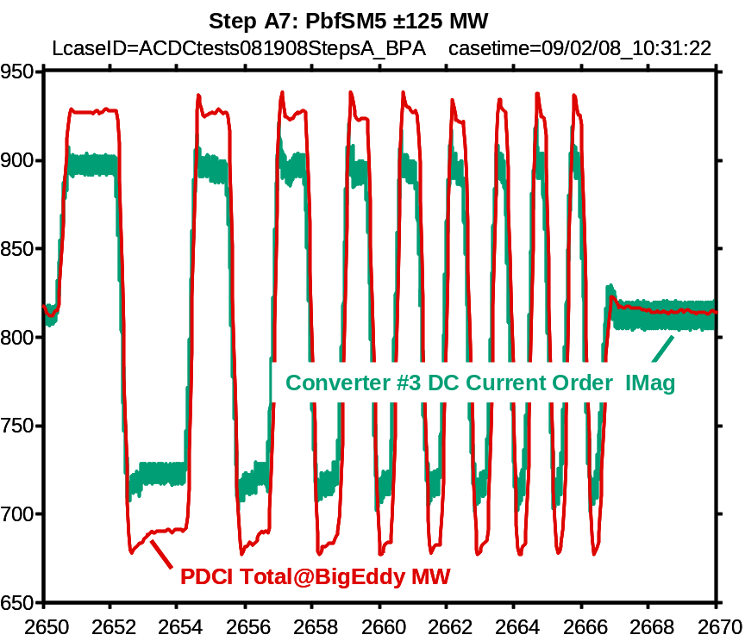
Fig. 52. Celilo PPSM vs. Big Eddy PMUs: Step A7

Cross Validation of Records from the Dittmer PPSM
The Dittmer PPSM is located at the Dittmer Control Center, and is usually set to collect data at 30 sps. Fig. 53 through Fig. 55 show that this unit was well synchronized to the phasor networks.
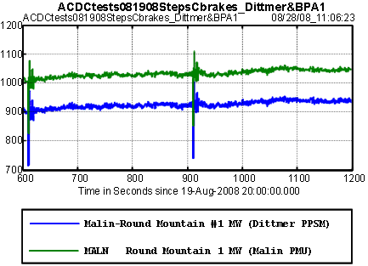
Fig. 53. Dittmer PPSM vs. Malin PMU: Brake insertions C1 & C2

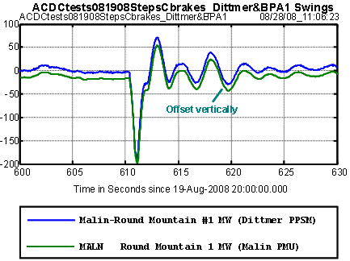
Fig. 54. Dittmer PPSM vs. Malin PMU: Brake insertion C1
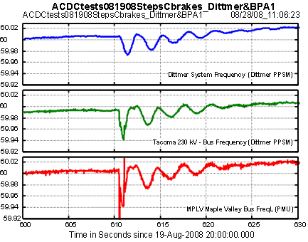
Fig. 55. Dittmer PPSM frequencies vs. Maple Valley PMU: Brake insertion C1

Cross Validation of Records from Special PPSM Units
[need data from the Kemano PPSM and similar point-on-wave units]

Actuator Performance of the Pacific HVDC Intertie
Modulating the current on an HVDC line produces real and reactive power injections into the ac system at each terminal So, considered as an actuator for the current modulation signal, the PDCI has one controlling input but six cross coupled outputs.
The relative strengths and phases of the complex power injections depend upon the nature of the modulation, and upon existing power system conditions. System conditions also affect dynamic response to the individual injections. Results summarized in [Error: Reference source not found] suggest that system response to reactive power injections can approach that for real power injections, and that this response may be strongly affected by voltage support at the terminal.
PDCI activity is rich in harmonics, not all of which are at multiples of the power system frequency. Measurements and analysis must be done with close attention to this environment, and with an expectation that some harmonics above the fundamental might be modulated by the probing signal.
Fig. 56 through Fig. 61 indicate the PDCI signal environment for ambient conditions during step B1 on August 19, 2008. The Celilo PPSM unit was set to record at 960 sps, and is GPS synchronized to the WECC phasor networks.
Fig. 56 shows a conspicuous peak, near 0.75 Hz, which was conspicuous in spectral analyses throughout the test period. It is also visible in the waterfall plot of Fig. 57, which shows the spectral content for low level probing with playback file MSF-1/6/100 in test step B2. Post analysis shows that the peak is present in all three PMUs that meter the PDCI. The full extent of this activity is still under investigation.
Fig. 58 and Fig. 59 show signals that are typical for ambient conditions during the test period. The autospectrum in Fig. 60, which shows conspicuous activity at the first four harmonics, is typical as well. Fig. 61 argues that the PMUs are relatively immune to the extraneous noise seen by the Celilo PPSM, probably because the (Macrodyne) filters provide good rejection at harmonics of 60 Hz. Fig. 60 shows substantial noise between the harmonics, however, and analysis will be made to determine the extent to which this is aliased into the PMU outputs. [need graphics, discussion of PMU simulation]
The PDCI noise levels shown here seem substantially higher than those noted in earlier tests. This too is a matter for further attention.

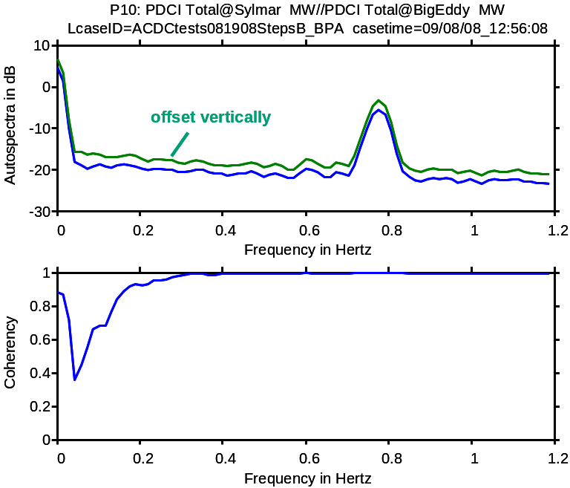
Fig. 56. Ambient autospectra during test event B1 on August 19, 2008
(PMU data, TRange=[0 1700] seconds)
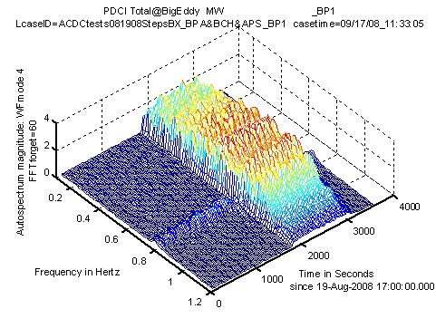
Fig. 57. Waterfall plot for variations in PDCI power—steps B
(bandpassed data)
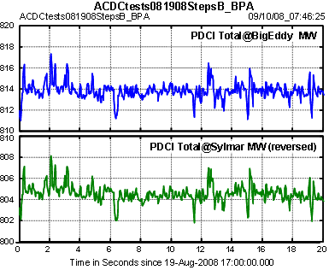
Fig. 58. Ambient signals during test event B1 on August 19, 2008
(PMU data for the PDCI)
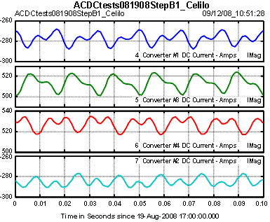
Fig. 59. Ambient signals during test event B1 on August 19, 2008
(data from Celilo PPSM)

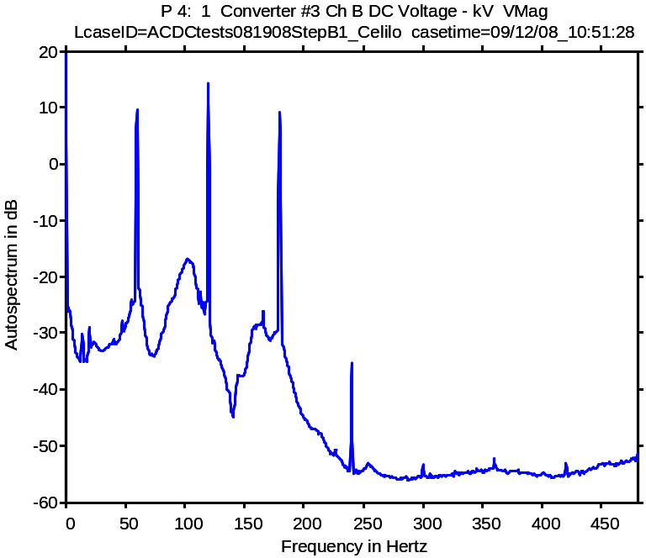
Fig. 60. Ambient autospectra during test event B1 on August 19, 2008
(data from Celilo PPSM)
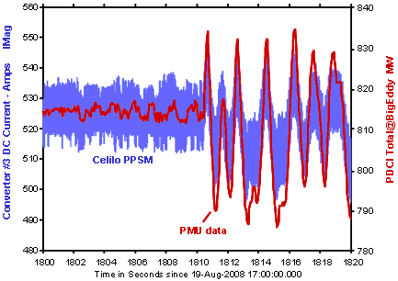
Fig. 61. Signal noise at start of test event B2: Celilo PPSM vs. PMUs

Initial Results with ModeMeter Codes
Broadly described, a ModeMeter is an integrated suite of analysis and display tools for real-time tracking of oscillatory dynamics. A perspective on the ModeMeter functionalities and technology is presented in [Error: Reference source not found], and is based upon long term experience in the WECC WAMS [Error: Reference source not found].
[need material here]

Conclusions
The tests produced an excellent profile of WECC dynamics across the entire grid. Response to probing signals was strongly observable in the western regions, and clearly apparent at eastern locations such as Four Corners and NE Colorado. The most recent tests, in August 2006 and August 2008, benefited from newly installed PMUs at several generation sites in western Canada. Several of these plants are critical to wide area dynamics, and this extension to WAMS coverage is a major contribution to surveillance of wide area interactions across the western interconnection.
Spectral signatures for brake insertions in the tests of 2006 and 2008 fit a general pattern that extends back to energization of the 500 KV Alberta connection in 1987. The insertions on 09/14/05 match a different but equally consistent pattern that results when the Alberta connection is not in service. It is strongly recommended that the M&VWG use these patterns as a general check on the realism of WECC planning models.
The damping for the principal interarea modes was rather high for brake insertions during all three tests. By comparison, during the late 1990’s damping for the first three modes was often near to 6%.; prior to that time a damping of 4.5% for the North-South mode was not unusual.
System conditions on 09/14/05 represented a normal but uncommon system topology, for which the Alberta mode is not present and frequency of the North-South mode is much higher. Data from the tests in 2005 and 2006 were subjected to very thorough analysis, and the values shown for them in Table 1 are benchmark results that are representative for a number of signal combinations and analysis procedures. While results for the 2008 test represent work in progress, final results are not expected to differ materially from those shown in the table.
Of particular note, the tests with low level noise demonstrated good results with a probing signal that roughly doubles the apparent noise that is natural to the power system. This additional noise is essentially invisible to all but the closest examination, and would probably be acceptable for general use as a background tool for surveillance of system dynamic conditions.
ModeMeter codes for this purpose were applied to system noise records. Results consistent with those for Prony analysis of brake insertions appears to require a record length of roughly 20 minutes. The development of these algorithms is being pursued very actively, and detailed progress is reported in a separate series of documents.
The data employed in the analysis were collected on just three PDC units plus a few secondary monitors. Even so, the data were contributed by eight or more operating utilities and provide a good overview of wide area dynamics for the entire system. Additional records, provided by other data owners, are available as backup to those shown here and for more detailed analyses that will be performed in the future.

Acknowledgements
The work reported here draws upon the contributions of far more people than are indicated in the author list. Existence of the WECC WAMS itself is largely due to efforts of the DMWG, the M&VWG, and other technical groups with an interest in the measurement, modeling, and control of wide area dynamics. The performance of staged tests would not be feasible without the endorsement of these same groups, together with the direct assistance of grid operators and data owners across the WECC system. These contributions are recognized and greatly appreciated.

Glossary of Terms
Table 8. Guide to general acronyms
DSA Dynamic Signal Analyzer
DSM Dynamic System Monitor
GPS global positioning satellite
IMU Information Management Unit
PDC Phasor Data Concentrator
PMU Phasor Measurement Unit
PPSM Portable Power System Monitor
PSM Power System Monitor (primary definition)
" Power System Measurements (secondary definition)
RTDMS Real Time Dynamic Monitoring System
SCADA Supervision Control and Data Acquisition
SPM Synchronized Phasor Measurements
SSM Synchronized System Measurements

AGC automatic generation control
FACTS Flexible AC Transmission System
HVDC high voltage direct current
PSS power system stabilizer
SVC static VAR compensator
TCSC thyristor controlled series capacitor

EIPP Eastern Interconnection Phasor Project
WACS Wide Area Control System
WAMS Wide Area Measurement System

ISO Independent System Operator
NERC North American Electric Reliability Council
WECC Western Electricity Coordinating Council
WSCC Western Systems Coordinating Council (predecessor to WECC)
AEP American Electric Power Co.
APS Arizona Public Service Co.
BCH British Columbia Hydro & Power Authority
BPA Bonneville Power Administration
PNNL Pacific Northwest National Laboratory
WAPA Western Area Power Administration
MT Montana Tech

DMWG Disturbance Monitoring Work Group of the WECC
M&VWG Monitoring & Validation Work Group of the WECC
PVTF Performance Validation Task Force of the M&VWG

COI California-Oregon Interconnection
PACI Pacific AC Intertie
PDCI Pacific DC Intertie

pow point on wave
sps samples per second

DSI Dynamic System Identification
FFT Fast Fourier Transform
PRS Prony Solution
LMS Least Mean Square
N4SID Numerical algorithms for Subspace State Space System Identification
RLS Recursive Least Squares
RRLS Robust RLS
YW Yule-Walker
YWS Yule-Walker Spectral

Table 9. PMU names and locations
PMU tags in configuration file BPA2_060508m.ini
GC50 Grand Coulee500
JDAY John Day
MALN Malin
COLS Colstrip
BE23 Big Eddy 230
BE50 Big Eddy 500
SYLM Sylmar
MPLV Maple Valley
KEEL Keeler
CPJK Captain Jack
SUML Summer Lake
SLAT Slatt
SCE1pmu0 SCE Vincent
SCE1pmu1 SCE Devers
MCN2 McNary 230
MCN5 McNary 500
ASHE Ashe 500
BEL5 Bell 500
BEL2 Name=Bell 230_A
BEL3 Bell 230_B
CHJ5 Chief Joe 500
CHJ2 Chief Joe 230_A
CHJ3 Chief Joe 230_B
CST5 Custer 500
CST2 Custer 230
AULT Ault
BEAR Bears Ears
SHIP Shiprock
YELT Yellowtail
MDW5 MIDWAY 500
DCPP Diablo Canyon
TSL5 Tesla 500
ML50 Moss Landing 500
PTSB Pittsburg 230

PMU tags in configuration file _BCH062006X.ini
ING1 Ingledow
DMR1 Dunsmuir
NIC1 Nicola
WSN1 Williston
SEL1 Selkirk
MIN1 Minette
REV1 Revelstoke
MCA1 Mica
GMS1 GMShrum1
GMS2 GMShrum2
LA01 Langdon
LAB1 Test PMU in BCH Lab

PMU tags in configuration file _APS1_060725.ini
FC50 Four Corners 500
FC30 Four Corners 345
NV50 Navajo 500
PP30 Pinnacle Peak 345
PV50 Palo Verde 500
HA50 Hassayampa 500
KY50 Kyrene 500
WW51 West Wing500-Navajo
WW52 West Wing500-Yavapai
WW53 West Wing500-Palo Verde1
WW54 West Wing500-Palo Verde2
WW25 WWG XFMR 1 230
WW26 WWG XFMR 4 230
WW27 WWG XFMR10 230

APPENDIX A. Test Sequence for August 19, 2008 [adjust timing data]
All times shown below are in Pacific Daylight Time (PDT), and seven hours behind GMT (or universal time).

Test Series A: Calibration Checks on PDCI Probing Signals
Step A0 [9:00] Celilo instrumentation check using +/-10MW waveform. Check proper function of PSG using Celilo/Sylmar DC metering.
Step A1 [9:10] Calibration check on MSF-20/6/17 for ±5 MW noise probing to determine HVDC pole response. Noise bandwidth will be 20 Hz. Adjust scaling of Probing Signal Generator (PSG) if needed.
Step A2 [9:15] Apply MSF-20/6/17 for ±5 MW noise probing to determine HVDC pole response. Expected duration is 5 minutes or less.
Step A3 [9:20] Calibration check on MSF-1/6/100 for ±10 MW noise probing of inter-area modes. Adjust PSG scaling if needed.
Step A4 [9:25] Apply MSF-1/6/100 for ±10 MW noise probing of inter-area modes. Expected duration is 10 minutes, but additional time may be needed for coordination of real-time observations at remote locations.
Step A5 [9:40] Apply PbfSM2 for single-mode probing ±125 MW. Waveform will be three cycles of a sine wave at 0.25 Hz.
Step A6 [9:42] Apply PbfSM3 for single-mode probing ±125 MW. Waveform will be three cycles of a sine wave at 0.70 Hz.
Step A7 [9:44] Apply PbfSM5 ±125 MW intermediate level short-term probing wave.

Test Series B: Noise Probing
Step B1 [10:10] Measurement of ambient noise conditions
Step B2 [10:30] Apply a +20 MW MSF-1/6/100 for a duration of 12 periods (20 minutes).

Test Series C: Cross Validation of Probing Methods
Step C1 [13:10] Insertion C1 of the Chief Joseph Dynamic Brake
Step C2 [13:15] Insertion C2 of the Chief Joseph Dynamic Brake, five minutes after insertion B1
Step C3 [13:20] Apply a +20 MW MSF-1/6/100 for a duration of 15 periods (25 minutes). Additional time may be needed if powerflow shifts or discrete control actions are noted during the test interval.
Step C4 [13:47] Apply PbfSM5 ±125 MW intermediate level short-term probing wave.
Step C5 [13:49] Apply PbfSM5 ±125 MW intermediate level short-term probing wave.

Test Series D: Noise Probing
Step D1 [14:10] Measurement of ambient noise conditions
Step D2 [14:11] Apply a +10 MW MSF-1/6/100 for a duration of 21 periods (35 minutes).
Step D3 [14:47] Apply PbfSM5 ±125 MW intermediate level short-term probing wave.
Step D4 [14:49] Apply PbfSM5 ±125 MW intermediate level short-term probing wave.

Test Series E: Noise Probing
Step E1 [15:10] Measurement of ambient noise conditions
Step E2 [15:11] Apply a +20 MW MSF-1/6/100R for a duration of 21 periods (35 minutes).
Step E3 [15:47] Apply PbfSM5 ±125 MW intermediate level short-term probing wave.
Step E4 [15:49] Apply PbfSM5 ±125 MW intermediate level short-term probing wave.

Test Series F: Noise Probing
Step F1 [16:10] Measurement of ambient noise conditions
Step F2 [16:11] Apply a +15 MW MSF-1/6/100 for a duration of 21 periods (35 minutes).
Step F3 [16:47] Apply PbfSM5 ±125 MW intermediate level short-term probing wave.
Step F4 [16:49] Apply PbfSM5 ±125 MW intermediate level short-term probing wave.

Test Series G: Brake Application
Step G1 [17:10] Insertion G1 of the Chief Joseph Dynamic Brake.
Step G2 [17:15] Insertion G2 of the Chief Joseph Dynamic Brake, five minutes after insertion G1
Step G3 [17:20] Apply a +20 MW MSF-1/6/100 for a duration of 15 periods (25 minutes).
Step G4 [17:47] Apply PbfSM5 ±125 MW intermediate level short-term probing wave.
Step G5 [17:49] Apply PbfSM5 ±125 MW intermediate level short-term probing wave.

APPENDIX B. Playback Files for HVDC Probing
HVDC probing signals were produced by adding a modulation signal to the HVDC current order for each of the Celilo pole controls. The process consisted of the following steps:
1. The test signal was developed in Matlab, with the scaling normalized to 1 MW.
2. The normalized test signal was translated into a Comtrade file and exported to an accessory computer (Matlab utility PSGwriteA.m)
3. The normalized test signal was scaled to the desired magnitude, then examined for correctness and loaded into a server acting as the Probing Signal Generator (PSG)
4. The PSG controls were set to play the scaled test signal a certain number of times.
5. The PSG utility was activated, thus playing the scaled test signal through the associated D/A converter and into the pole controls for the indicated number of times. Scale factor = 8 dc amperes for 1 volt.
A detailed description of the PSG is provided in [,].
[Expand discussion here—Greg?]

Table 10. Menu of Playback Files for HVDC Probing on August 19, 2008

File Name | Test | Type | Band Width or Frequency | Amplitude
MSF-20/6/17 | A | Multi-sine fitted | 20 Hz 6th filter | +/- 5 MW
MSF/1/6/100 | A | Multi-sine fitted | 1 Hz 6th order filter | +/- 5 MW
MSF/1/6/100 | C | Multi-sine fitted | 1 Hz 6th order filter | +/- 10 MW  (5 x 2 multiplier)
MSF/1/6/100 | E | Multisine fitted | 1 Hz 6th order filter | +/- 15 MW (5 x 3 multiplier)
MSF/1/6/100 | D,F,G | Multisine fitted | 1 Hz 6th order filter | +/- 20 MW (5 x 4 multiplier)
MSF/1/6/100R | D,F,G | Reverse in time of MSF/1/6/100 above | 1 Hz 6th order filter | +/- 20 MW (5 x 4 multiplier)
PbfSM2 | A,B | Sine single mode | 3 cycle 0.25 Hz | +/- 125 MW
PbfSM3 | A | Sine single mode | 3 cycle 0.7 Hz | +/- 125 MW
PbfSM5 | A-E,G | Intermediate level | 0.2 to 2.0 Hz sweep | +/- 125 MW

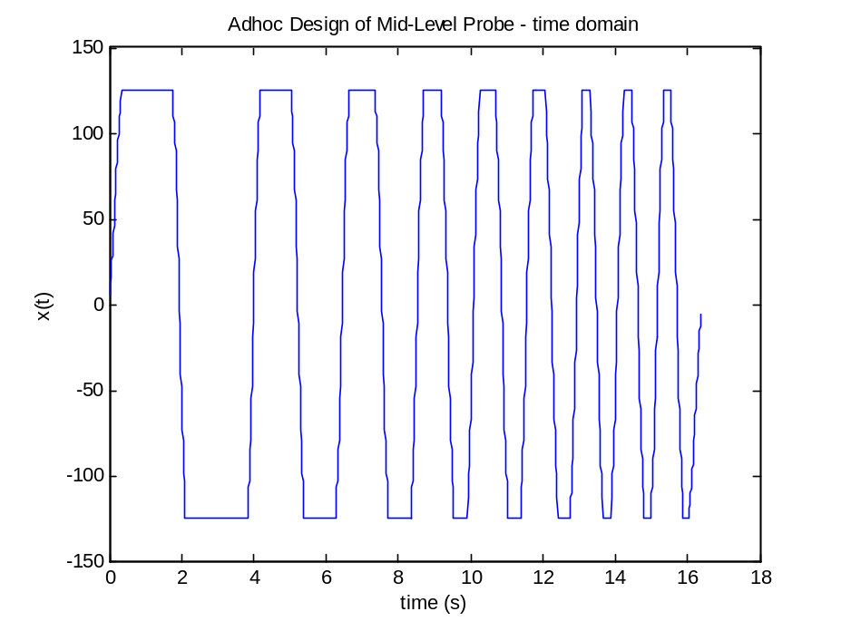
Figure 10. ±125 MW intermediate level short-term probing wave (PbfSM5)

APPENDIX D. DSA Applications During Low Level HVDC Probing
The basic strategy in low level probing is to start with a very weak probing signal, and to progressively adjust that signal to the minimum level that produces acceptable results. Key real-time resources for this are PDC StreamReaders, accompanied by an add-on Dynamic Signal Analyzer (DSA) tool for spectral analysis [].
Topology of the HVDC probing tests can be represented by Fig. 62, where the indicated test points provide the following quantities:
Test Point A
HVDC modulation signal, presented to the Celilo pole controls as a current order. Recorded by the Celilo PPSM at 960 samples per second (sps).
Test Point B
– HVDC voltages & currents at Celilo converters, plus various HVDC control signals. Recorded by the Celilo PPSM at 960 sps.
– AC bus and line quantities at Celilo converters. Recorded by BPA phasor measurement network at 30 sps.
Test Point C
AC bus and line quantities at key locations across the western interconnection. Recorded by WECC phasor measurement networks at 30 sps, and by other WECC facilities at a variety of sample rates.
As yet there is no real time integration of the dc and the ac measurements at test point B. The notation B_{dc} and B_{ac} will be used to distinguish between the two classes of signals there.
Actuator response of the Celilo pole controls was observed in real time by means of a hardware DSA connected from test point A to test point B_{dc}, in addition to other local instruments at Celilo.
AC system response to HVDC modulation was observed in real time with PDC StreamReaders in combination with the StreamReader DSA. Topology for this aspect of the system measurements is shown in Fig. 63. The DSA functionality appears there in two places, as a StreamReader add-on and as an element of the DSI Toolbox. At present the DSI Toolbox is only applied off line.
Fig. 64 and Fig. 65 show typical displays for the PDC StreamReader, and for the StreamReader DSA. While this may not have been necessary, the spectrogram displays (in Fig. 65) have been turned off to minimize computational burden on the supporting PC units. FFT settings used in the DSA are shown in Fig. 66, which expands the lower portion of Fig. 65.
Overviews of underlying mathematics for DSA calculations can be found in [,,]. Specific documentation for the DSA itself is desirable.
[Expand discussion to include RTDMS & ModeMeter]

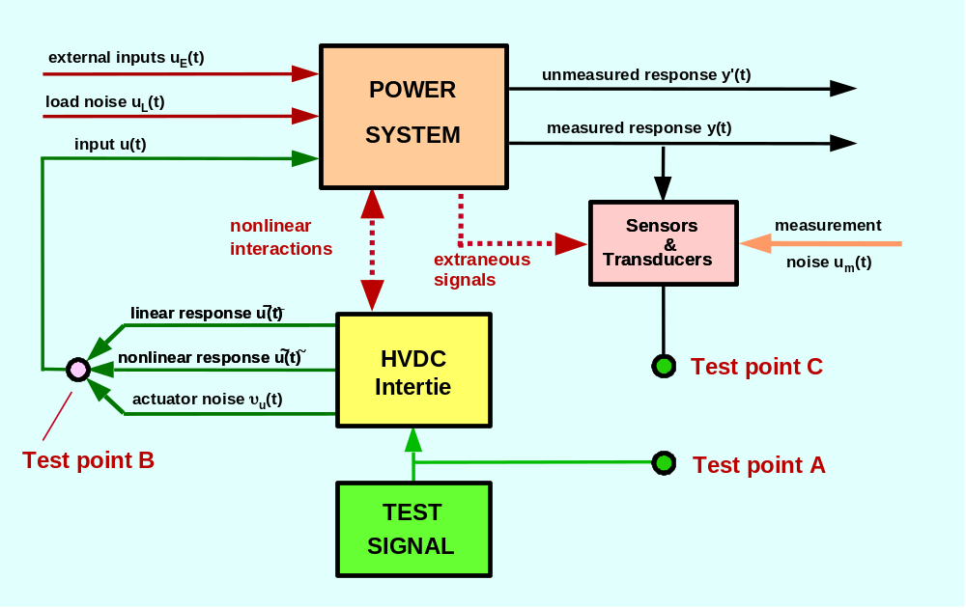
Fig. 62. General environment for probing tests based upon HVDC modulation
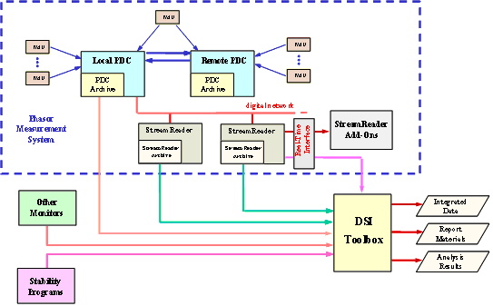
Fig. 63. Integration and analysis of WAMS data
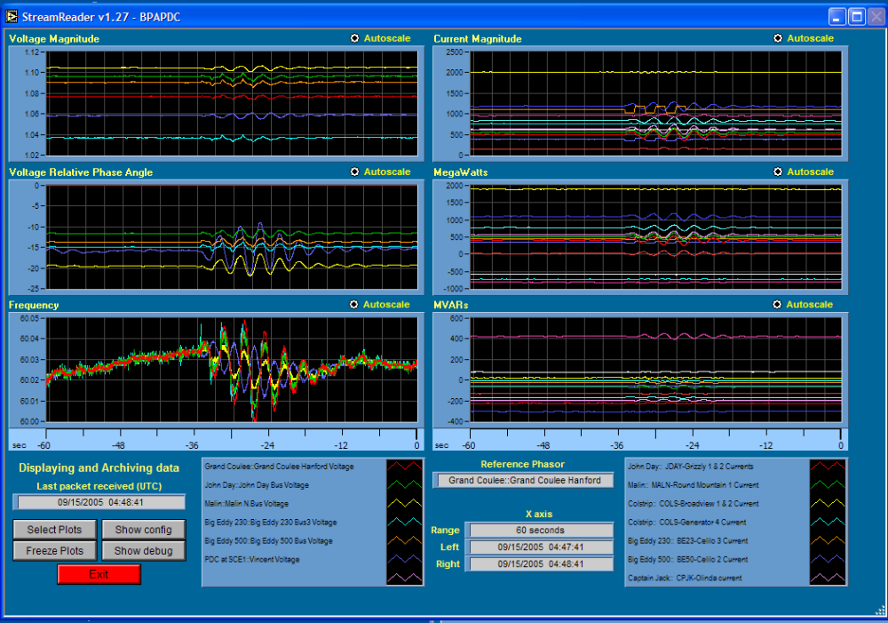
Fig. 64. StreamReader window during Test Step E3-7: single-mode square burst @ 0.3 Hz

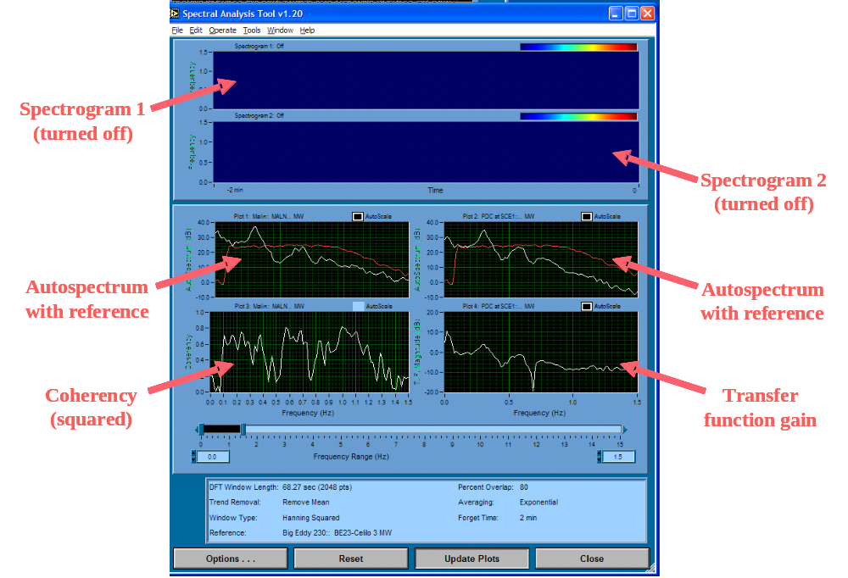
Fig. 65. StreamReader DSA window during Test Step C3: noise probing @ 20 MW
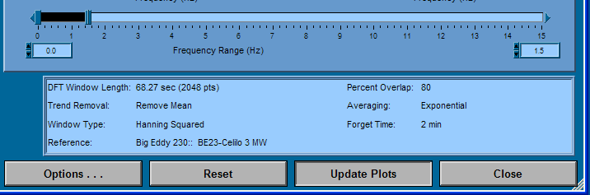
Fig. 66. FFT settings for StreamReader DSA

References

A more detailed PMU table is provided in 17.0, Glossary of Terms
Damping of the Kemano mode on 09/14/05 was very high, and the estimate was quite variable.
PMUs of different vintages and types may employ markedly inconsistent logic for calculating bus frequency.
APS data for the Palo Verde-Devers line are a preferred alternative, in part because it provides a broader view of system voltage quantities.
An alternative is to estimate the recovery transient on a long window, and the oscillatory modes on short windows. The DSI Toolbox provides several mechanisms for doing this.
A Hewlett-Packard HP3562A unit
[?] Use of the WECC WAMS in Staged System Tests for Validation of System Performance and Modeling: Summary Report for September 2005–August 2006, J. F. Hauer, W. A. Mittelstadt, J W. Burns, K. E. Martin, Harry Lee, and D. J. Trudnowski. Interim report of the WECC Disturbance Monitoring Work Group, April 25, 2007. (Available at ftp://ftp.bpa.gov/pub/WAMS_Information/)
[?] Use of the WECC WAMS in Wide Area Probing Tests for Validation of System Performance & Modeling, J. F. Hauer, W. A. Mittelstadt, K. E. Martin, J. W. Burns, Harry Lee, J. W. Pierre, and D. J. Trudnowski in association with the WECC Disturbance Monitoring Work Group. Submitted for publication in IEEE Trans. Power Systems.
[?] Integrated Dynamic Information for the Western Power System: WAMS Analysis in 2005, J. F. Hauer, W. A. Mittelstadt, K. E. Martin, J. W. Burns, and Harry Lee. Interim report of the WECC Disturbance Monitoring Work Group, December 2005. (available at ftp://ftp.bpa.gov/pub/WAMS%20Information/, and in The Electric Power Engineering Handbook, edition 2, L. L. Grigsby ed., CRC Press, 2007)
[?] WAMS Analysis Tools for Tracking of Oscillatory Dynamics, J. F. Hauer, D. J. Trudnowski, and J. D. DeSteese. Presented at the 2007 PES General Meeting in Tampa, Florida, June 24-28, 2007.
[?] August 4th Oscillations: Analysis of Possible Effects of Control System Tunings, B. Corm, J. Jardim, and M. Kwok. BCH internal report provided to the Disturbance Monitoring Work Group, October 31, 2000.
[?] “Initial Results in Power System Identification from Injected Probing Signals Using a Subspace Method," N. Zhou, John Pierre, and J. F. Hauer. IEEE Trans. Power Systems, vol. 21, issue 3, pp. 1296-1302, August 2006.
[?] "Robust RLS Methods for On-Line Estimation of Power System Electromechanical Modes," N. Zhou, J. W. Pierre, D. Trudnowski, and R. Guttromson. IEEE Trans. Power Systems, Volume 22, Issue 3, Aug. 2007 pp. 1240-1249.
[?] “Performance of Three Mode-Meter Block-Processing Algorithms for Automated Dynamic Stability Assessment,” D. J. Trudnowski, J. W. Pierre, N. Zhou, J. F. Hauer, and M. Parashar. IEEE Trans. on Power Systems, vol. 23, no. 2, May 2008, pp. 680-690.
[?] “Estimating Electromechanical Mode Shape from Synchrophasor Measurements”, D. J. Trudnowski. IEEE Transactions on Power Systems, vol. 23, no. 3, pp. 1188-1195, Aug. 2008.
[?] A Perspective on Use of the Pacific HVDC Intertie for Wide Area Tests of Western Power System Dynamics, J. F. Hauer. WAMS Working Note developed under BPA/EPRI Tailored Collaboration, June 10, 1997. (Attachment to WAMS Information Manager Report EPRI Report TR-112031, May 1999)
[?] Interim Report on the Model Validation Tests of June 7, 2000 -- Part 1: Oscillatory Dynamics, principal investigator J. F. Hauer. WSCC Performance Validation Task Force (PVTF) of the Modeling and Validation Work Group, October 26, 2000. Available at Internet site http://www.wecc.biz/committees/PCC/TSS/MVWG/documents/ (address out of date?)
[?] Dynamic Performance Validation in the Western Power System, J. F. Hauer, M. J. Beshir, and W. A. Mittelstadt in association with WSCC work groups. APEx 2000 Conference in Kananaskis, Alberta, October 2000. (Available at ftp://ftp.bpa.gov/pub/WAMS%20Information/)
[?] September 2005 Staged System Tests for Validation of WECC System Performance and Modeling—Summary Report, J. F. Hauer et al. WAMS Working Note, partial draft of March 23, 2006.
[?] September 2005 Staged System Tests for Validation of WECC System Performance and Modeling— Response of PDCI Terminal Quantities to Current Modulation, J. F. Hauer. WAMS Working Note, partial draft of June 6, 2006
[?] Performance Validation and Noise Injection Staged Tests – Test Plan Comprehensive Report. WAMS Working Note distributed August 30, 2005 and updated Sept 12, 2005 to reflect small changes in test schedule.
[?] Performance Validation and Noise Injection Staged Tests. BPA Memorandum distributed as a test notice on August 30, 2005 and updated Sept 12, 2005 to reflect small changes in test schedule.
[?] Performance Validation and Noise Injection Staged Tests [TEST PLAN]. BPA Memorandum distributed to the WECC, May 26, 2006.
[?] Juang, J. N. 1994. Applied System Identification. Prentice-Hall, city, state????.
[?] Van Overshee, P. and B. De Moor. 1996. Subspace Identification for Linear Systems. Kluwer Academic Publishers, city, state??.
[?] Hauer, J. F, "Power System Identification by Fitting Structured Models to Measured Frequency Response," IEEE Trans. PAS, pp. 915-923, April 1982.
[?] R.W. Wies, J.W. Pierre, and D.J. Trudnowski, “Use of ARMA Block Processing for Estimating Stationary Low-Frequency Electromechanical Modes of Power Systems,” IEEE Transactions on Power Systems, vol. 18, no. 1, pp. 167-173, Feb. 2003.
[?] Anderson, M.G., N. Zhou, J.W. Pierre, and R.W. Wies, “Bootstrap-based Confidence Interval Estimates for Electromechanical Modes from Multiple Output Analysis of Measured Ambient Data,” IEEE Transactions on Power Systems, vol. 20, no. 2, pp. 943-950, May 2005.
[?] "Initial Results in Power System Identification from Injected Probing Signals Using a Subspace Method," N. Zhou, J. Pierre, and J. F. Hauer. IEEE Trans. Power Systems, vol. 21, issue 3, pp. 1296-1302, August 2006.
[?] A User Guide to PSM Tools: Utilities for Matlab Processing of Power System Response Records, J. F. Hauer and J. M. Johnson. Prepared for the U.S. Department of Energy Transmission Reliability Program by the Consortium for Electric Reliability Solutions (CERTS), February 2001. (Available at ftp.bpa.gov/pub/WAMS%20Information/).
[?] DSItools User Manual for the Ringdown Analysis Tool, J. M. Johnson and D. J. Trudnowski. Battelle Memorial Institute, 1998.
[?] Probe Server User's Guide, K. E. Martin and others. BPA internal report, March 1999.
[?] Probe Client User's Guide, K. E. Martin and others. BPA internal report, March 1999.
[?] Report on September 2005 Staged System Tests for Validation of WECC System Performance and Modeling-- Performance of the Dynamic Signal Analyzer (DSA) Tool Interfaced to the PDC StreamReader, J. F. Hauer. WAMS Working Note, partial draft of October 6, 2005.
[?] Engineering Applications of Correlation and Spectral Analysis, J. S. Bendat and A. G. Piersol. New York: John Wiley, 1980.
[?] A User Guide to PSM Tools: Utilities for Matlab Processing of Power System Response Records, J. F. Hauer and J. M. Johnson. Prepared for the U.S. Department of Energy Transmission Reliability Program by the Consortium for Electric Reliability Solutions (CERTS), February 2001. (Available at ftp.bpa.gov/pub/WAMS%20Information/).
[?] "Using the Coherency Function to Detect Large-Scale Dynamic System Modal Observability," D. J. Trudnowski, J. F. Hauer, J. Pierre, W. H. Litzenberger, and D. J. Maratukulam. Proceedings of the 1999 American Control Conference, pp. 2886-2890, San Diego, CA, June 1999.

